# Advancements in Citrus-Based Biorefineries: A Comprehensive Review of Bioprocess **Designs,** Processing Techniques and Value-Added Products

Recent years have seen a significant increase in research on citrus processing, particularly in the development of citrus-based biorefineries (CBB). With over 20 conceptual designs for processing biomass into high-value bioproducts, CBB presents a promising solution for the sustainable utilization of citrus waste. This review examines the recent milestones achieved in the intersection of food processing and CBB, including the development of green technologies, the prospecting of novel bioproducts, and the optimization of biomass integrated processing designs. The findings from this review shed light on the current state of the art in CBB and provide a basis for future research in this field.

## Chemical Composition of Citrus **fruits**: Implications for Biorefinery Applications

The genus Citrus and its associated genera, namely Fortunella, Poncirus, Eremocitrus, and Microcitrus, are classified under the angiosperm subfamily Aurantioideae of the Rutaceae family. This taxonomic classification system is widely accepted within the scientific community, although there has been an interesting recent taxonomic discussion proposed from omics sciences (Wu et al., 2018).

Mahato et al. (2018) proposed a comprehensive schematic diagram delineating the components of citrus fruits (Figure_citric_parts). Citrus fruits are composed of edible parts, namely the pulp and juice, as well as non-edible parts, commonly known as citrus waste, which includes the segment wall, flavedo and albedo, pitch residue, and seeds. Such a classification enables a holistic comprehension of the diverse components of citrus fruits, which may facilitate the development of biorefinery processes for the extraction of maximum value from citrus fruits. In particular, the inclusion of citrus waste in the biorefinery process is of paramount importance as it accounts for nearly 50% of the total biomass weight of citrus fruits. These insights may have significant implications for the development of sustainable and economically viable approaches for citrus processing, which can offer a promising avenue for the valorization of citrus waste and the creation of value-added products.

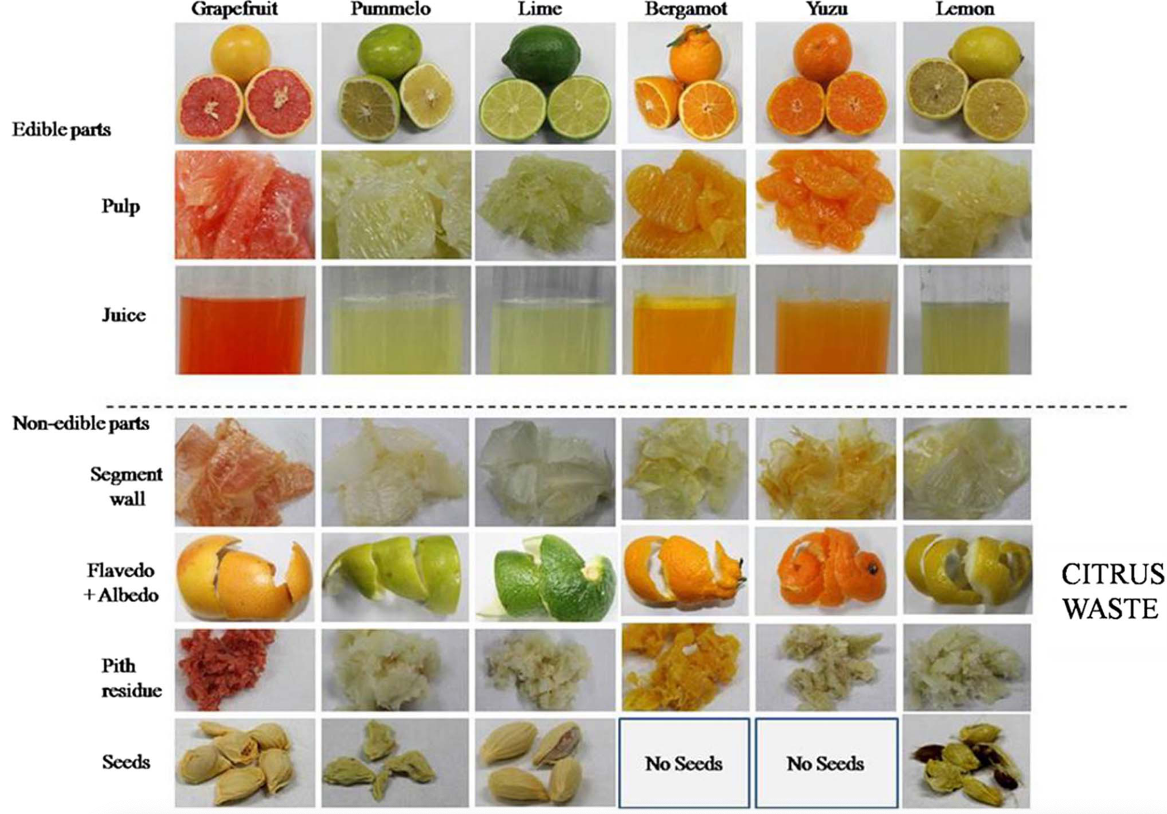

Figure Figure_citric_parts Citrus fruits parts (Mahato et al., 2018)

[Table Chemical composition of citrus fruits](https://doi.org/10.1016/j.biortech.2022.128215)

| Composition | Lemon | Lime | Mandarin | Orange | Grapefruit |
| --- | --- | --- | --- | --- | --- |
| Water (%) | 89.3 | 88.2 | 85.2 | 86.8 | 90.9 |
| Carbohydrates (g/100g) | 2.5 | 3.0 | 11.8 | 8.3 | 6.7 |
| Fiber (g/100g) | 2.8 | 2.8 | 1.8 | 2.4 | 1.1 |
| Protein (g/100g) | 1.1 | 0.7 | 0.8 | 1.0 | 0.5 |
| Fat (g/100g) | 0.3 | 0.2 | 0.3 | 0.2 | 0.1 |
| Vitamin C (mg/100g) | 53.0 | 29.1 | 26.7 | 53.2 | 33.3 |
| Citric acid (g/100g) | 4.6 | 6.0 | 1.8 | 1.9 | 1.7 |
| Flavonoids (mg/100g) | 22.3 | 10.6 | 21.9 | 22.0 | 17.5 |
| Limonoids (mg/100g) | 4.4 | 4.4 | 0.7 | 0.5 | 0.5 |
| Essential oils (g/100g) | 0.25 | 0.25 | 0.05 | 0.05 | 0.10 |

Source: (U.S. Department of Agriculture, Agricultural Research Service, 2019)

In citrus fruits, the physical composition is mainly comprised of juice (40-70%), followed by rag and pulp (20-40%), albedo (5-15%), flavedo (2-5%), and seeds (2-3%). The chemical composition of citrus fruit is complex and water is the most abundant component (about 80-90%). Citrus fruit is also a source of micronutrients such as vitamins (C, A, B1, B2, B6, and E), minerals (potassium, magnesium, calcium, and phosphorus), and carotenoids. Furthermore, citrus fruit contains bioactive compounds like flavonoids, limonoids, and coumarins, which contribute to its health benefits. The exact composition of citrus fruit may vary depending on the species, cultivar, growing conditions, and other factors. The chemical composition of citrus fruits can be analyzed through a comprehensive approach, as exemplified by Table 1. This table presents an overview of the major chemical constituents of different citrus varieties, including organic acids, sugars, vitamins, and minerals, among others. By providing a detailed understanding of the chemical profile of citrus fruits, this approach can inform the development of biorefinery processes that aim to extract and utilize specific components for various applications in the food, pharmaceutical, and chemical industries.

Jeong et al. (2021) conducted a comprehensive review of the chemical composition of various citrus biomass, providing a valuable overview of the major constituents such as carbohydrates, proteins, lipids, and lignocellulosic compounds. This detailed analysis of citrus biomass enables the development of effective biorefinery processes, which can extract high-value products from these materials. The authors compare the composition of citrus biomass to that of other types of biomass, highlighting the unique features and potential advantages of citrus as a promising source for bioproducts with high commercial value. The findings of this study suggest that citrus-based biorefineries hold great potential for the sustainable production of a wide range of bioproducts.

Galanakis (2019) has provided a comprehensive overview of the chemical composition of dried and wet citrus fruit waste in Table_Character_citrus_waste, which serves as a valuable resource for understanding the characteristics of these materials. In addition, Zema et al. (2018) have compiled the mean values of the physico-chemical composition of citrus peel waste in Table_mean_composition, which offers useful insights into the composition of citrus waste. The information presented in these tables can be utilized to develop novel processes and products based on citrus waste.

Table Table_Character_citrus_waste

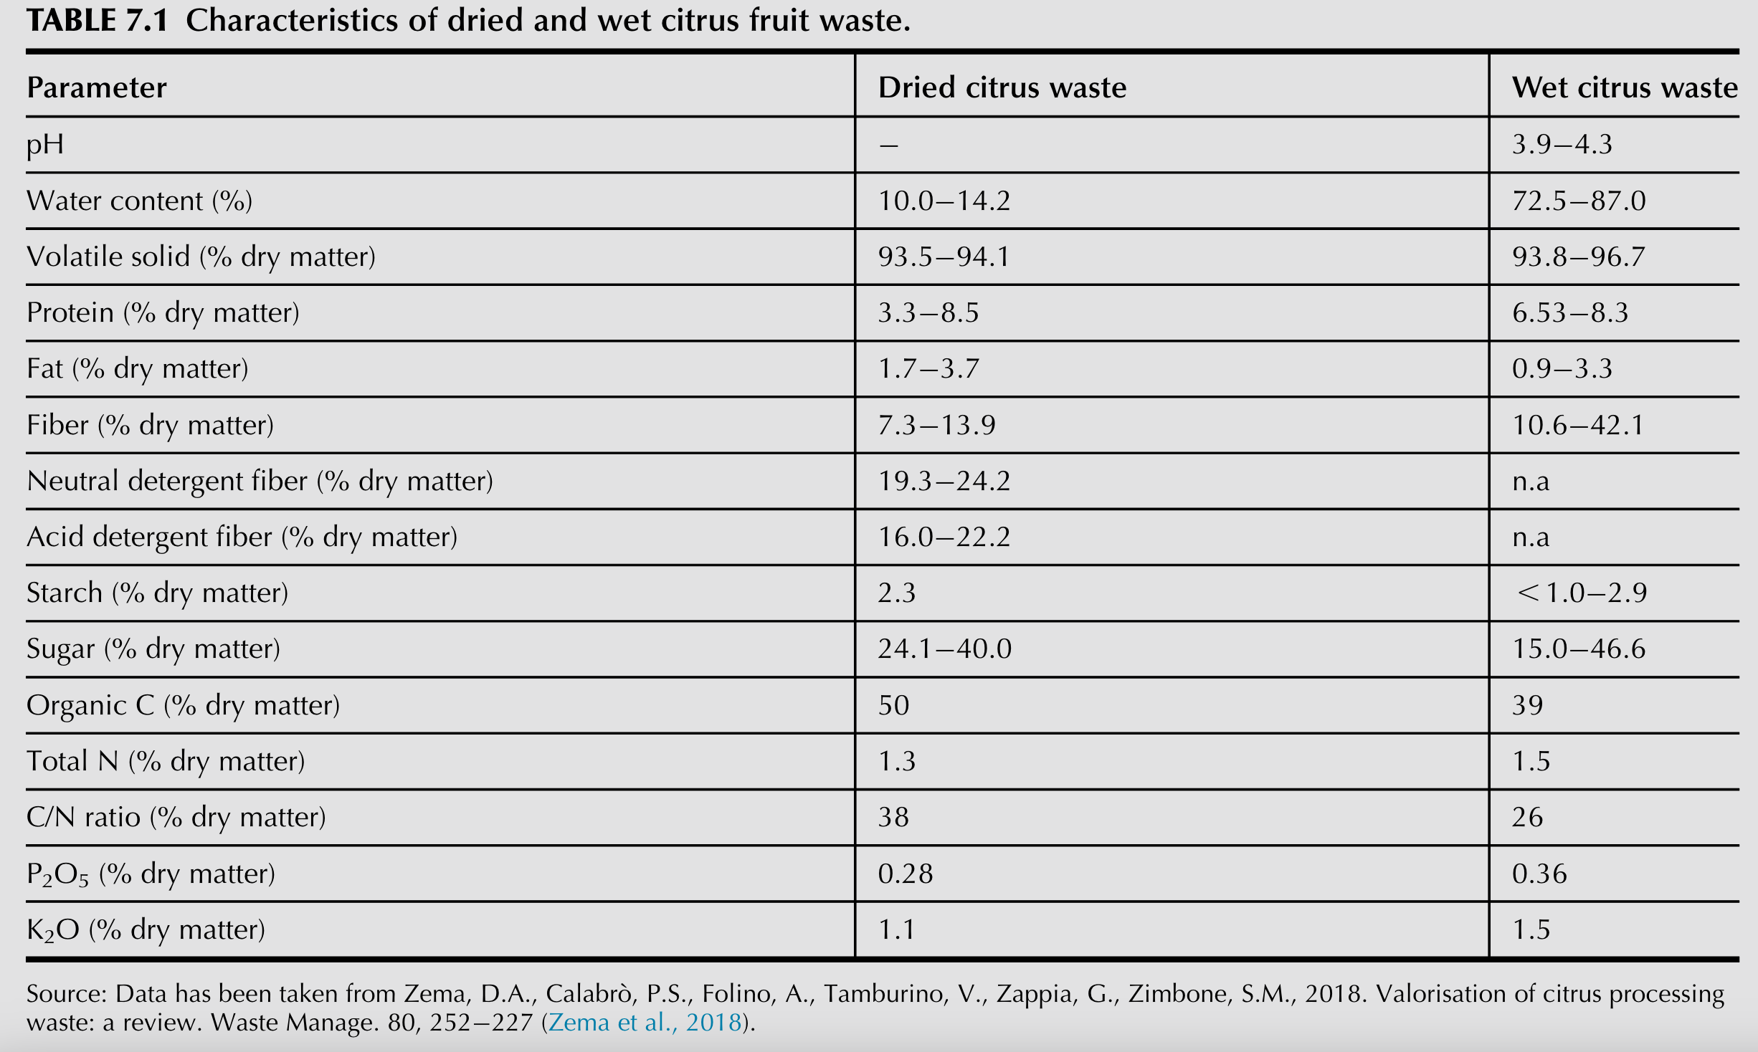

Table Table_mean_composition Mean value of physico-chemical composition of citrus peel waste (Zema et al., 2018)

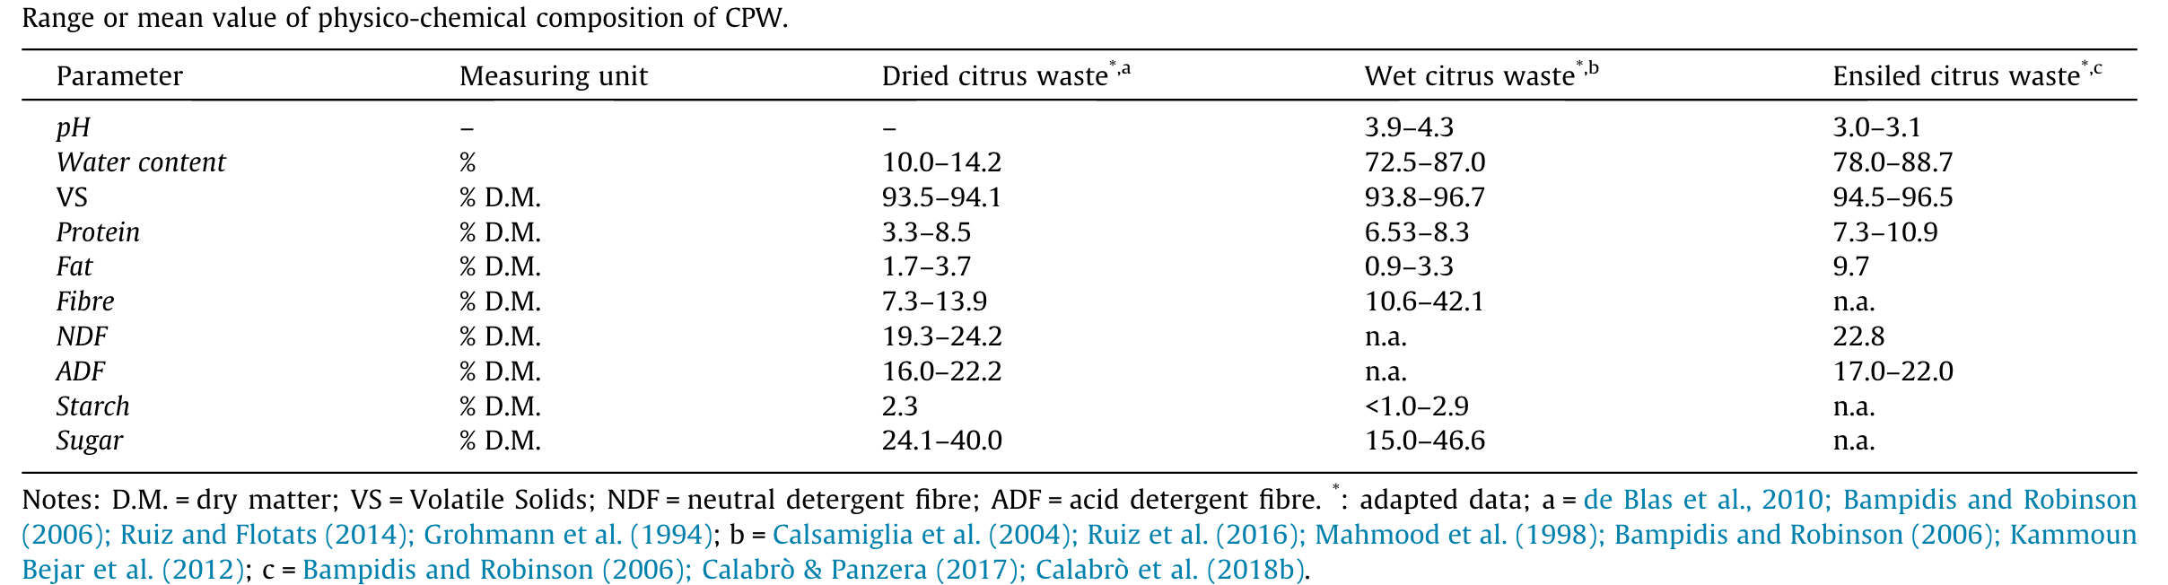

To enhance the completeness of our data and address any gaps in our information, we consulted additional sources of information including (Harrington et al., 2019), (Instituto Colombiano & de Bienestar Familiar, 2018) and (U.S. Department of Agriculture, Agricultural Research Service, 2019) for the purpose of comparing and cross-referencing data.

The abundance of citrus waste generated during processing presents an opportunity to obtain high-value products and improve the citrus agroindustrial chain. However, these waste materials are often not utilized and instead disposed of in a manner that contributes to environmental pollution and greenhouse gas emissions (Negro et al., 2017), (Teigiserova et al., 2022), (Satari & Karimi, 2018). Fortunately, there have been several research studies focused on the integral utilization of citrus waste through the application of CBB-based approaches. These studies provide valuable insights into the development of new processes and products that can add value to the citrus industry while reducing waste and environmental impact.

## Bioprocess designs in citrus based biorefineries

Reviews of the valorization of citrus waste have been conducted by various authors. Among them (Yadav et al., 2022) focus on biorefinery valorizartion approach, also (Klimek-Szczykutowicz et al., 2020) attend to citrus lemon bioactives compounds, while (Rafiq et al., 2018) summarized the potential components present in citrus peel, as well as (Mahato et al., 2018) focus on citrus waste derived nutra-/pharmaceuticals for health benefits.

Similarly (Zema et al., 2018) review literature and discuss citrus processing systems and citrus peel waste production and storage as well as citrus peel waste valorization systems, where the authors distinguish between systems that make direct use of biomass and biorefinery valorization approaches.

In the same way (Putnik et al., 2017) and (Negro et al., 2016) review the most important studies of valorization of citrus processing, while (Mamma & Christakopoulos, 2014) engage in biotransformation of citrus by-products reviewing attempts that have been made to generate several value-added products, such as essential oils, pectin, enzymes, single cell protein, natural antioxidants, ethanol, organic acids, and prebiotics.

Mamma & Christakopoulos (2014) provided a summary of the main proposed biorefinery designs in their review. One of the earliest proposed biorefinery designs was presented by Ángel Siles López et al. (2010) in which a conceptual biorefinery produces a portfolio of high-value products, including essential oils, pectin, industrial enzymes, single cell proteins, ethanol, methane, and heat. Various processing technologies, such as solvent extraction, acid hydrolysis, fermentation, and combustion, were used to extract and convert the valuable components from citrus waste (see Figure Figure_Angel_Siles2010) (see Figure Figure_Angel_Siles2010)

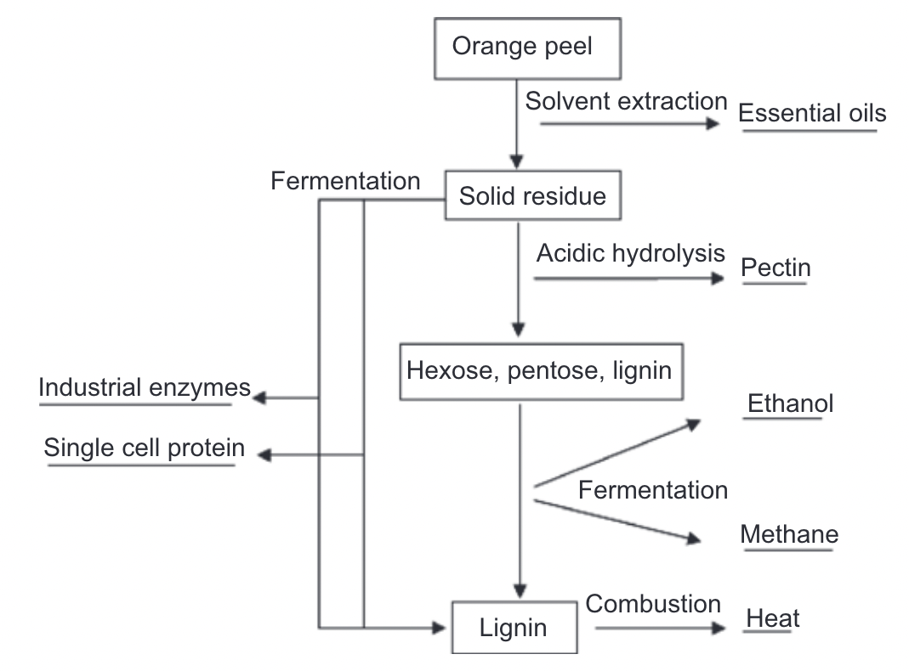

Figure Figure_Angel_Siles2010. (Ángel Siles López et al. 2010). Citrus based biorefinery conceptual design.

Ángel Siles López et al., (2010) identified several key elements for further research in the area of biorefinery design. These include: (a) the need for greater knowledge of the chemical constituents of orange peel to detect more high-value products, (b) the design of chemical engineering processes that can adapt to a variety of feedstocks, (c) the development of microbial strains that are more efficient at converting orange peel into high-value products using classic mutagenesis or metabolic engineering, and (d) the integrated study of orange peel treatment steps, where the residues obtained in one step are used as raw material in the following one, according to the definition of a biorefinery facility.

A process design and economic analysis were carried out by (Lohrasbi et al., 2010). They propose a process composed of dilute-acid hydrolysis, fermentation, recovery of ethanol, anaerobic digestion, and wastewater treatment. In the economic analysis, they found that with the constant price of methane and limonene, changing the plant capacity from 25,000 to 400,000 tons CW per year results in reducing ethanol costs from 2.55 to 0.46 USD/L in an economically feasible process.

Pourbafrani et al., (2010) propose a method for commercial treatment of CW to yield different value-added products including ethanol, biogas, limonene and pectin. By applying this process, 39.64 l ethanol, almost 45 m3 pure methane, 8.9 l limonene, and up to maximum 38.8 kg pectin can be produced per ton of the wet CW. It is an integrated process, in which the ethanol produced in the process can be used for pectin recovery, and the produced methane can be utilized in a steam boiler to generate steam required for distillation and hydrolysis* The authors stated that the simplicity of the process and low price of biomass compared to other ethanol processes from lignocelluloses make this process unique and favorable. However, further economic optimizations are required to investigate the profitability of the process.

Rezzadori et al. (2012) work with orange juice industrial production proposing alternatives to reduce and valorize the liquid and solid residues. The authors proposed 6 systems with their respective economic and environmental benefits, as well as investments required. Each system is focus on a main bioproduct, system 1 ingredients for animal feed, Bio-oil and charcoal system 2, essential oils system 3, pectin production system 4, solid residue as adsorbent system 5, and system 6 integrated process for production of ethanol, biogas and limonene.

Balu et al. (2012) report a novel approach they called cascade-type valorization to convert whole waste orange peels into high-value bioproducts by using a single-step, low-temperature hydrothermal microwave treatment (see Figure Figure_Balu2012). Products obtained include d-limonene, pectin, and an unusual form of mesoporous cellulose. Authors reported "for the first time", the in situ conversion of d-limonene into $\alpha$ -terpineol.

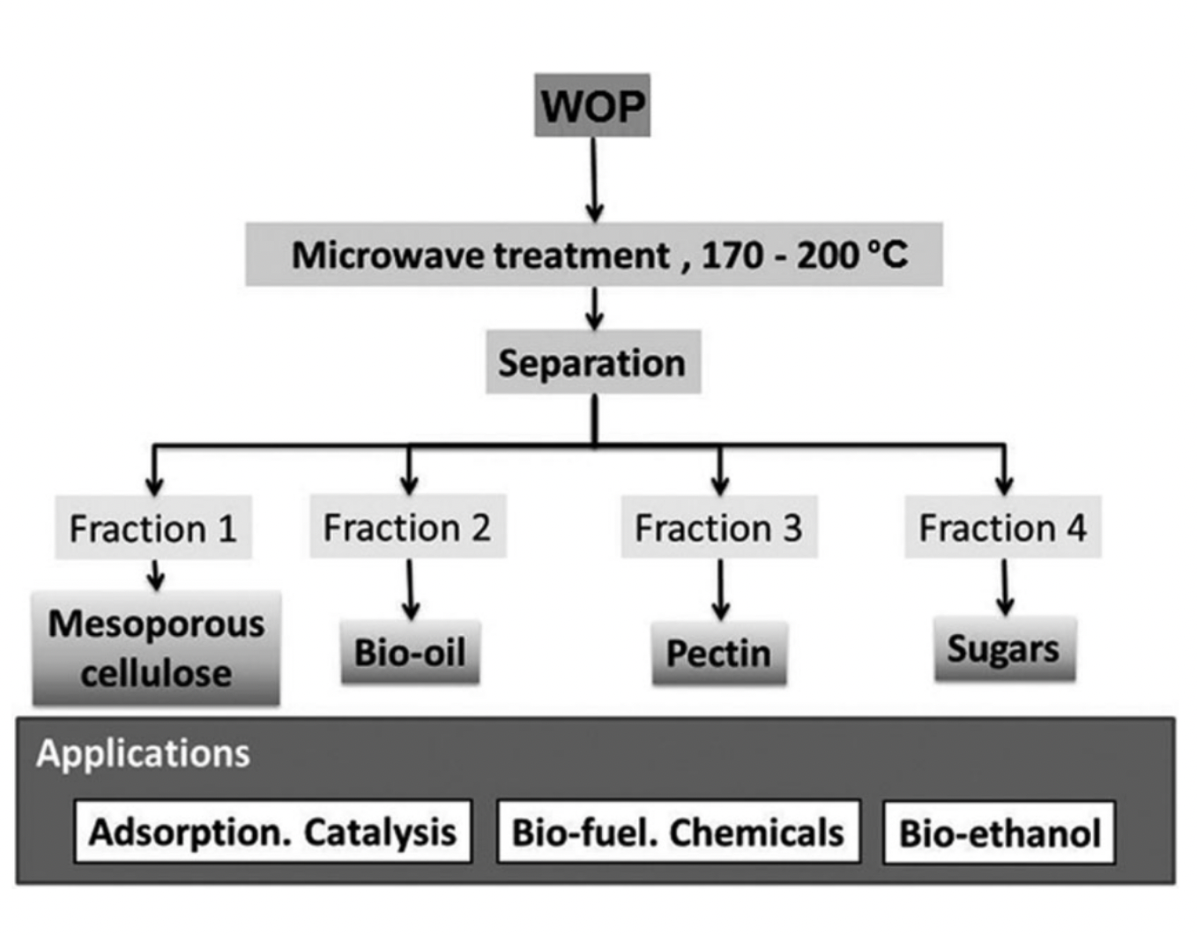

Figure Figure_Balu2012). Microwave hydrothermal pyrolysis of waste orange peel (Balu et al., 2012)

Moncada-Botero, J., (2012). Evaluated a citrus based biorefinery for the integrated production of essential oil, concentrated juice, antioxidant, citrus seed oil, pectin, xylitol, PHB, ethanol, citric acid, lactic acid and electricity. For all scenarios feedstock consist in 100 tonnes/h of fresh citrus fruit (for orange and mandarin) (equivalent to 800000 tonnes/year for a working year of 8000 hours). Feedstock quantity is very large in proportion to the current Colombian plantations, representing around the 430% of Colombian productivity, which is very low and not competitive in the World market.

Rivas-Cantu et al. (2013) propose some integrated physico-chemical pretreatments for citrus processing waste (CPW), this pre-treatments include high speed knife-grinding and simultaneous caustic addition. They conclude that the effect of this new processes in reduction of particle size and the increased surface area for the CPW will result in higher reaction rates and monosaccharide yields for the pretreated waste material.

Boukroufa et al., (2015) report that extraction of essential oil, polyphenols and pectin from orange peel has been optimized using microwave and ultrasound technology without adding any solvent but only "in situ" water which was recycled and used as solvent. This green approach was compared with conventional extraction methods and seems to have a good performance in terms of yields of extraction, time of the process and energy consumption.

(Dávila et al., 2015) report a Techno-economic and environmental assessments for producing essential oils, pcymene and pectin from orange peel. Two scenarios were assessment with and without electricity generation, the one without electricity generation turns out to be the best scheme reaching a production cost of 5.27 and 3.53 USD/kg of pcymene and pectin respectively.

Fidalgo et al. (2016) report a comparative study of processing waste orange and lemon peel using only water as dispersing medium and microwaves as energy source. They reported being the ability of scaling up the process for lemon peels, while the yield, quality, and environmental viability of the extracted pectin and EOs were comparable on experimental and semi-industrial scales.

Focus on green technology and its engineering challenges (Satari & Karimi, 2018) propuse a conceptual scheme for biorefinery of citrus peels. The authors concludes that citrus processing waste is a promising sustainable biowaste residue for biorefineries, with potential for producing biosorbents, nanomaterials, organic fertilizer, pectin, bioactives/nutraceuticals, and essential oils. However, questions remain regarding optimization of extraction methods, avoiding thermal degradation, and cost-effectiveness on an industrial scale. The future of biowaste management lies in the exploitation of value-added chemicals and strategies for preventing environmental collapse. Further R&D development is needed in this area.

Joglekar et al., (2019) conducted a Life Cycle Assessment (LCA) for a representative citrus waste biorefinery. The functional unit used for LCA was set as 2500 kg of CW processed. The overall Global warming potential (GWP) was observed to be 937.3 kg CO2 equivalent per 2500 kg of CW processed. Hydrolysis and flashing contributing to around 60% to midpoint indicators (Acidification potential AP, Eutrophication potential EP, and Photochemical ozone creation potential POCP). However, the contribution of hydrolysis and flashing was 14% only to Ozone depletion potential (ODP).

Hilali et al. (2019) established a biorefinery that utilized solar hydrodistillation (SSD) for extracting essential oils, polyphenols, and pectins from citrus. The study revealed that the peels still retained total phenol compounds (TPC), total flavonoid contents (TFC), hesperidin, narirutin, and pectin in significant amounts even after undergoing high preservation measures, particularly during the process of solar hydro-distillation.

At the forefront of biofuel research, Patsalou et al. (2019) have developed an innovative method for biofuel production that utilizes solid residues through repeated batch anaerobic digestion fermentations. Their research has yielded impressive results, demonstrating methane formation rates of 342 mL $gvs^{−1}$ (volatile solids). Additionally, their work has shown that untreated and dried CPW can be effectively used to produce methane, with similar methane production levels ranging from 339-356 mL $gvs^{−1}$. These findings have significant implications for the development of sustainable energy sources, highlighting the potential for efficient and effective biofuel production using solid residues.

Santiago et al. (2020) proposed a novel approach for the valorization of residual side-streams in citrus-based biorefineries, with the primary objective of producing d-limonene as the main target product. The proposed strategy, known as "closing the loop", involves the production of biogas and digestate as co-products through anaerobic digestion of residual side-streams. The authors carried out plant-wide simulations for four different scenarios to evaluate the environmental impact and economic feasibility of the proposed approach. The results highlighted the need for further optimization of the purification stages to minimize the environmental impact of the proposed scenarios with poor environmental profiles. This study provides valuable insights into the potential of integrating anaerobic digestion and citrus-based biorefineries for sustainable production of high-value compounds.

Yadav et al. (2022) present a comprehensive review of the current state of citrus waste management and biorefinery. A schematic model for citrus waste biorefinery is proposed, providing a clear and practical framework for utilizing the various components of citrus waste, including peel, pulp, and seeds, to produce value-added products such as essential oils, biofuels, and biodegradable plastics. The review highlights the potential of citrus waste as a sustainable and economically viable resource, and underscores the importance of developing efficient biorefinery processes to maximize its utilization and minimize waste. Overall, this work represents an important contribution to the field of biorefinery and sustainable waste management, with implications for both industry and academia.

Myrtsi et al. (2022) present a novel approach to enhance the extraction of carotenoids from citrus, utilizing azeotropic condensation. This methodology demonstrated improved yields in both the qualitative and quantitative recovery of carotenoids. Furthermore, the authors were able to isolate two important chemicals, namely D-limonene (500 g cold pressing essential oils CPEO: 53.5 mg β-cryptoxanthin, 435 g D-limonene (>95%)), and coumarins (109-158 g). The significant quantities of coumarin fraction represent a promising avenue for future research and exploitation.

Table Feedstock, Product, and Remarkable Observation Summary for Reviewed Biorefineries

| Feedstocks | Products | Remarks | Author |
| --- | --- | --- | --- |
| Orange peel | High-value products (e.g. ethanol, biogas, limonene, pectin) | Further research on chemical constituents of orange peel, design of adaptable chemical engineering processes, and development of efficient microbial strains needed for conversion | Ángel Siles López et al. (2010), Pourbafrani et al. (2010), Cerón & Cardona (2011), Rezzadori et al. (2012), Balu et al. (2012), Moncada-Botero, J. (2012), Rivas-Cantu et al. (2013), Boukroufa et al. (2015), Dávila et al. (2015) |
| Orange peel | Ethanol | Dilute-acid hydrolysis, fermentation, recovery of ethanol, anaerobic digestion, and wastewater treatment process, economically feasible | Lohrasbi et al. (2010) |
| Orange peel | d-limonene, pectin, mesoporous cellulose | Cascade-type valorization through low-temperature hydrothermal microwave treatment | Balu et al. (2012) |
| Citrus fruit | Essential oil, concentrated juice, antioxidant, citrus seed oil, pectin, xylitol, PHB, ethanol, citric acid, lactic acid, electricity | Evaluation of citrus-based biorefinery for integrated production of multiple products | Moncada-Botero, J. (2012) |
| Citrus processing waste (CPW) | Monosaccharide | New physico-chemical pre-treatments to increase reaction rates and monosaccharide yields for the pretreated waste material | Rivas-Cantu et al. (2013) |
| Orange peel | Essential oil, polyphenols, pectin | Extraction optimization using microwave and ultrasound technology, and recycled water as solvent | Boukroufa et al. (2015) |
| Orange peel | Essential oil, pcymene, pectin | Techno-economic and environmental assessments for production, scenario without electricity generation had best production cost | Dávila et al. (2015) |
| Processing waste orange and lemon peel | Essential oil, pectin | Comparative study of processing waste orange and lemon peel using only water as dispersing medium and microwaves | Fidalgo et al. (2016) |

## Citrus processing technologies

### Citrus juice extraction

Citrus juices are typically obtained through a process known as citrus juice extraction. This process involves several steps that are designed to extract the juice from the fruit while minimizing the amount of pulp and other solids that end up in the final product. The first step in the process involves washing the fruit to remove any dirt or debris that may be present on the surface. The fruit is then sorted by size and quality, with any damaged or rotten fruit being discarded. Once the fruit has been sorted, it is typically fed into a machine called a citrus juicer. Citrus juicers use a combination of spinning blades and pressure to break open the fruit and extract the juice. The juice is then separated from the pulp and other solids using a filter or centrifuge. After the juice has been extracted, it is typically pasteurized to kill any bacteria or other microorganisms that may be present. This helps to extend the shelf life of the juice and ensure that it is safe to consume. Finally, the juice is typically packaged in bottles, cartons, or other containers and shipped to grocery stores, restaurants, and other outlets where it can be sold to consumers (U.S. Department of Agriculture, Agricultural Research Service, 1956).

Nnamdi et al. (2020) discusses the various types of agricultural equipment used for post-harvesting of orange fruit juice, with a focus on juice extraction. The history of juice extraction is reviewed, highlighting the progress from the traditional, tedious method of squeezing to automated juice extracting machines. The four types of juice extractor machines are described, including manual and electric operation, and the benefits of fruit juice consumption are briefly mentioned. The authors emphasizes the need for affordable and user-friendly machines, as well as portable machines for easy juice extraction. Overall, the paper provides a useful overview of the technology used for orange juice extraction, and its potential health benefits.

Jesus et al. (2007) presents a study on the concentration of single-strength orange juice using reverse osmosis in a pilot plant with 0.72 m2 of filtration area. The study evaluates the effect of three different transmembrane pressures on the concentration factor, soluble solids content, and vitamin C content of the concentrated juice. The permeate flux is also analyzed for each pressure. The study concludes that it is feasible to concentrate orange juice by reverse osmosis while maintaining its sensory and nutritional characteristics. The reconstituted juice obtained by reverse osmosis had a better-preserved flavor compared to thermal evaporation. The paper provides valuable insights into the potential applications of reverse osmosis for orange juice concentration.

The design and fabrication of a small scale motorized orange juice extractor using locally-available materials is a noteworthy contribution to the development of the agricultural sector in rural communities. Olaniyan (2010) reported that the machine exhibited an average juice yield and juice extraction efficiency of 41.6% and 57.4%, respectively, with a capacity of 14 kg/h. At a cost of approximately $100, the affordability of the machine renders it accessible to small-scale citrus farmers in rural areas, thereby augmenting their income-generating capacity. This research can serve as a blueprint for the development of similar machines for other crops and fruits, thus stimulating the growth of small-scale agro-based industries in rural communities.

### Pectin extraction

Pectin is a complex polysaccharide found in the cell walls of fruits and vegetables. Pectin is extracted from citrus peels by subjecting them to extraction, followed by concentration, precipitation, and drying (Ceron & Cardona, 2011). Pectin extraction can be carried out by different methods, including conventional acid extraction, chelating agents, enzymatic extraction, ultrasound-assited extraction and microwave-assisted extraction[1]. The factors that influence the extraction process include temperature, pH, extraction time, type of acid, and ratio of water to raw material. Although conventional acid extraction is the most suitable for industrial extraction, alternative non-conventional methods are being researched due to environmental issues surrounding the disposal of hazardous chemicals. Enzyme-assisted extraction requires lower temperatures and less solvent than conventional acid extraction, but has disadvantages related to the high cost of enzymes and scalability issues. Microwave-assisted extraction is a non-conventional method that can reduce extraction time but may also result in pectin degradation (Kontogiorgos, 2020).

Pérez et al. (2012), concluded that during experimentation it was observed that high-quality Persian lime peels should be used because green fruits contain a higher amount of pectin than ripe ones. It is recommended to add concentrated HCl as an enzymatic inactivator and use isopropyl alcohol due to its more branched chemical structure, which leads to faster gelation and consequently, higher yields of pectin-based gel. During the drying kinetics, it was determined that a constant temperature of 75°C for 4.5 hours should be used. The final product had a moisture content of 11.87%, with a slight difference compared to commercial pectin, and a yield of 6.34%.

Prakash Maran et al., (2013) demonstrates the potential of microwave-assisted extraction for pectin extraction from dried orange peel. The Box-Behnken response surface design was used to optimize the process variables and develop a second-order polynomial model that adequately explained the relationship between independent variables and the response. The optimization study using Derringer’s desired function methodology led to the determination of optimal conditions with maximum pectin yield of 19.24%, which was confirmed through validation experiments. The results suggest that microwave-assisted extraction can be an efficient and promising method for pectin extraction from dried orange peel.

Garcia-Garcia et al. (2019) presents the first Life-Cycle Assessment of a microwave-assisted process for pectin production at a pilot scale, demonstrating that the resulting pectin meets all criteria for food-grade commercial pectin and the microwave process has <25% of the environmental impact of traditional acid-assisted thermal processes. The improved yield and reproducibility of the process suggest the practical and commercial potential of microwave technology in pectin production.

Tuan, et. al. (2019) presents a novel method for simultaneous extraction of pectin and essential oils from pomelo peels using a hydrodistillation process with the addition of citric acid. The results show that the addition of citric acid increases the pectin yield without affecting the yield or chemical composition of the essential oils. This approach presents a promising method for the extraction of both valuable components from pomelo peels in a single process, potentially reducing production costs and improving efficiency.

Koulouris & Demetri Petrides (2020) presents a model for a pectin production process in SuperPro Designer, with a focus on minimizing raw material requirements and associated costs. The model shows that a pectin manufacturing plant with a capacity of 5000 MT/year requires a total capital expenditure of $122 million and annual operating expenditures of around $56 million, with over 300 kg of water required per kg of pectin product stream. To reduce water usage and costs, a water recovery and recycling system is used, which significantly reduces the fresh water requirement but increases capital and utility costs. Heat recovery is also crucial in reducing utility consumption, and SuperPro Designer has the ability to incorporate virtual heat integration to estimate the impact of energy savings on production costs. Overall, this paper highlights the importance of optimizing resource usage and recovery to minimize costs and increase profitability in the pectin production process.

Singhal & Swami Hulle, (2022) presents a table summarizes the extraction of pectin from various citrus-based sources using conventional, microwave-assisted, ultrasound-assisted, and enzyme-assisted extraction methods. The table lists the fruit or fruit by-product used, the treatment method (solvent, temperature, time, pH), yield of pectin, galacturonic acid content, and degree of esterification. The data suggests that different citrus sources have different optimal extraction conditions and yields, with microwave and ultrasound-assisted methods generally yielding higher amounts of pectin than conventional methods. Enzyme-assisted extraction also shows potential for extracting pectin from citrus sources.

Sabater et al. (2022) highlights the growing interest in using by-products from the agrifood industry to achieve zero waste, with a focus on the comprehensive utilization of pectin residues from a biorefinery approach. The paper provides a general overview of valorisation strategies for fruit and vegetable byproducts, including the recovery of high-value ingredients, biofuels, and other fermentation products. The review emphasizes the importance of utilizing microbial glycosidases in fermentation processes and the potential for applying these strategies beyond citrus to other types of agri-food wastes.

### Essential oils extraction

Ferhat et al., (2007) compares and evaluates the effectiveness of traditional hydrodistillation (HD), cold pressing (CP), and innovative microwave ‘dry’ distillation or microwave-accelerated distillation (MAD) methods for the isolation of essential oils (EO) from fresh Citrus peels. The study indicates that the microwave method offers important advantages over traditional alternatives, including shorter extraction times, better yields, lower environmental impact, cleaner features, increased antimicrobial activities, and providing a more valuable essential oil. Scanning electron microscopy provides more evidence of the cleanness of microwave extraction. The study proposes and discusses a mechanism of microwave ‘dry’ distillation.

Pingret et al., (2014) focuses on the processing technologies of essential oils (EO) using a new process employing ultrasound technology to improve hydrodistillation extraction, called the sono-Clevenger process. The study indicates that the sono-Clevenger process provides a substantial reduction in the extraction time when compared to conventional Clevenger extraction, without interfering with the composition of target compounds. The extraction of essential oil from orange peels was compared with physicochemical characterization and gravimetric analysis.

Shakir & Salih, (2015) focuses on the processing technologies of essential oils (EO) from orange, lemon, and mandarin peels using steam distillation (SD) and microwave-assisted steam distillation (MASD). The study investigates the effect of extraction conditions such as weight of the sample, extraction time, and microwave power on oil yield and compares the results of the two methods. The resulting EO was analyzed by Gas Chromatography (GC). The study shows that MASD is better than SD in terms of rapidity, energy saving, and yield. The optimal microwave power was 135W, and the optimal weight was 398.56gm. The best citrus peel type which gave the highest yield was orange followed by lemon then mandarin in both processes. Limonene is the most abundant component in citrus EO. The GC analysis showed that SD was more convenient to give a high amount of limonene because of the gradual temperature rise, while in microwave extraction, exposure to low microwave power was observed to be suitable for limonene production. The study highlights the potential of microwave-assisted extraction as a green technique for the extraction of natural products.

Boukhatem, (2016) provides a thorough analysis of the efficiency and effectiveness of different processing technologies in the extraction of essential oils from various citrus fruits. The authors have compared and evaluated hydro-distillation, cold pressing, and microwave accelerated distillation methods, and have highlighted the advantages of the latter in terms of shorter distillation times, improved yields, lower energy costs, and cleaner features. The use of gas chromatography-mass spectrometry and principal components analysis to identify and compare the chemical constituents of the extracted essential oils is a sound scientific approach. This paper is of particular interest to those in the field of plant biology, as it provides valuable insights into the extraction of essential oils from citrus fruits using different methods, and highlights the potential benefits of using microwave accelerated distillation.

Bustamante, (2016) focuses on the use of microwave-assisted hydro-distillation (MAHD) as an alternative technique for the extraction of essential oils from wet citrus peel waste. The study considers the scalability of the process to develop a new bio-refinery model for industrial scale use. Optimal conditions for the essential oil MAHD involve the irradiation of a waste orange peel:water mixture over two subsequent steps for a total extraction time of 20 min at a constant pressure of 300 mbar. The essential oil yield obtained using MAHD was comparable to that obtained by conventional hydro-distillation. The study offers an attractive process for future extraction processes at industrial scale.

Chávez-González et al., (2016) discusses enzymatic pretreatments applied to orange, lemon, and grapefruit peels to increase essential oil yields extracted by hydrodistillation. The study shows that in two of the sources, essential oil yields increased from two to six times, indicating the potential of enzymatic pretreatment to improve the efficiency of essential oil extraction. The study also obtained a significant amount of fermentable sugars, which can be used to produce other compounds of interest through fermentation. This work contributes to the development of sustainable processes for the recovery of essential oils and other value-added products from citrus peel waste.

Golmohammadi et al., (2018) presents a new extraction process for obtaining essential oil from citrus peels, which involves steam explosion at high temperature and pressure. The steam explosion process involves subjecting the material to high-pressure saturated steam followed by a rapid drop in pressure through an angle valve to a vacuum tank. From a processing technology perspective, this paper highlights how steam explosion can drastically shorten the extraction time and improve essential oil yield compared to traditional hydro-distillation processes. Additionally, this paper provides insights into the differences in the composition of essential oils obtained through steam explosion and hydro-distillation processes, which is important for the food and fragrance industry.

Weng et al., (2019) shows that use of potassium carbonate as an activating agent for the extraction of essential oils from citrus peel is a promising method, as it not only enhances the extraction rate of essential oils but also generates a solid residue that can be used as a precursor for the production of activated carbons. The results of this study demonstrate the effectiveness of K2CO3 in promoting the extraction of essential oils, resulting in a significant increase in the extraction rate compared to regular steam distillation. Furthermore, the stability of the chemical composition of the extracted essential oils indicates their potential for direct use in the perfume industry.

Dao et al., (2020) focuses on the processing technologies of essential oils (EO) from lemon leaves using microwave-assisted hydro-distillation (MAHD) and optimizing it through response surface methodology. The selected parameters were water and material ratio, microwave power, and extraction time. The study indicates that a quadratic polynomial model could be employed to optimize the microwave extraction of essential oil from Lemon (Citrus aurantifolia) leaves. The optimal extraction conditions included microwave power of 523.89W, water to material ratio of 3.27 mL/g, and extraction time of 84.47 minutes. The study concludes that the optimized yield (0.76%) approached predicted yield predicted by the model, implying that the model is suitable to predict behavior of the process.

Song et al., (2022) proposes a novel method for extracting essential oils from citrus peel wastes using microwave heating. The paper investigates the content change rule and composition distribution of the product at different reaction times and microwave power levels. It also compares the efficiency and energy consumption of the microwave extraction method with conventional methods. The results show that the optimum microwave power and time were 450 W and 10 min, respectively, which yielded 29.22% liquid product with a 37.82% limonene yield. The paper proposes an extraction mechanism based on the heating and pumping effects of microwave energy. Overall, this study provides important insights into the use of microwave heating for the extraction of essential oils from citrus peel wastes, which has the potential to reduce energy costs and improve efficiency compared to traditional extraction methods.

### Antioxidants extraction

Singanusong et al., (2015) explores the ultrasound-assisted extraction (UAE) of phenolic compounds from mandarin and lime peels, which are known to be rich sources of these compounds. The UAE technique is an effective method for extracting phenolic compounds from plants due to its ability to save extraction time and increase extraction yields. The study utilized a factorial randomized complete experimental design to investigate the influence of various factors on the UAE using low power (50.93 W). The research focuses on the effect of citrus peel types and solvent types and concentrations on the total phenolic compounds, total flavonoids, and flavanone glycosides (hesperidin and naringin) in the extracts. Additionally, the antioxidant activity of the extracts was measured by ferric reducing antioxidant potential (FRAP), azinobis(3-ethylbenzthiazoline-6-sulfonic acid) (ABTS), and 1,1diphenyl-2-picrylhydrazyl (DPPH) assays. The results of the study show that the optimum extraction conditions occurred when mandarin peel and 80 % acetone were used. In those conditions, the extract contained a high concentration of total phenolic compounds (3,083.61 mg gallic acid equivalent (eq) 100 g−1 dry weight (DW)), total flavonoids (2,539.82 mg quercetin eq 100 g−1 DW), and hesperidin (1,374.20 mg 100 g−1 DW). The measured antioxidant activity was also significant, with a DPPH IC50 of 0.61 mg mL−1, an ABTS IC50 of 1.12mgmL−1, and a FRAP of 2,521.47 mg trolox eq 100 g−1.

Calinescu et al., (2017) highlights the development of a special microwave-assisted extraction equipment for obtaining natural compounds from plants without affecting their chemical structure. The equipment allows for microwave heating using a slot end coaxial antenna into a microwave applicator, providing an efficient cooling system to achieve a high specific absorption rate (SAR) at low temperatures. From a processing technology perspective, this research emphasizes the importance of developing equipment that can extract valuable compounds with minimal degradation, leading to higher yields and better quality products. The study also shows that the extracts obtained through this procedure have higher polyphenol content and antioxidant capacity than those obtained through conventional methods.

Sharma et al., (2019) discusses the extraction, characterization, and biological activity of citrus flavonoids, which are bioactive compounds found in citrus waste. The article highlights the importance of finding better methods for reusing citrus waste to obtain value-added phytochemicals and for safe disposal. From a processing technology perspective, this article emphasizes the importance of exploring efficient and cost-effective extraction procedures for obtaining these phytochemicals. The research findings indicate a strong correlation between total phenolic content and antioxidant activity. The study provides valuable insights into the optimization of UAE extraction conditions for obtaining phenolic compounds from mandarin and lime peels. The results can be useful in developing functional food products and nutraceuticals with high antioxidant activity, which can have significant health benefits. The research also highlights the potential of UAE as a green and sustainable extraction technique for obtaining bioactive compounds from natural sources.

Zayed et al., (2021) discusses various extraction methods for obtaining phytoconstituents from citrus seeds. Solvent extraction and supercritical CO2 extraction are the two most commonly used methods. Solvent extraction using non-polar solvents like n-hexane has been traditionally used, but the method has several disadvantages, such as toxicity and air pollution. Other extraction solvents like ethanol and methanol have been found to be more effective and safer. Supercritical CO2 extraction is a popular method for the rapid and efficient extraction of various chemicals from plant materials. The use of ethanol as a co-solvent with CO2 makes it more suited for the recovery of polar phenolics in citrus seeds. The paper also discusses fractionation or sequential extraction of seeds to optimize phytoconstituents isolation and improve biological activities. The methods discussed in the paper could help in the valorization of citrus seed byproducts for various purposes depending on the targeted chemical or intended use.

Phucharoenrak et al., (2022) shows a green extraction method for achieve highest yields in Limonin and Hespiridin from lime (citrus aurantifolia) peel powder. This paper presents a study on the development of a green extraction method for obtaining high yields of limonin and hesperidin from lime peel powder. The authors use a combination of ethanolic-aqueous extraction and the response surface methodology to optimize the extraction conditions. One of the strengths of the article is its focus on the use of renewable plant sources and environmentally friendly bio-solvents in the extraction process, which aligns with current research trends in the field. The authors also provide clear and detailed descriptions of the methods used in the study, including the equipment used for analysis, making it easy to replicate their experiment. In conclusion, the article presents a well-conducted study on the development of a green extraction method for obtaining high yields of limonin and hesperidin from lime peel powder.

Ashokkumar et al., (2023) provides a comprehensive overview of various extraction techniques for antioxidants, highlighting their advantages and disadvantages from a processing technology perspective. It is interesting to note that each technique has its unique benefits and limitations. For example, supercritical fluid extraction offers extreme changes in solvent properties and low adsorption on matrix constituents, but suffers from low solubility in carbon dioxide. On the other hand, microwave-assisted extraction has a faster heating process and reduced equipment size, but requires special equipment and has low selectivity. This information can be valuable for researchers and industries looking for efficient and cost-effective methods for antioxidant extraction.

### Oils extraction

Nwobi et al., (2011) study the extraction and characterization of oil from Citrus Sinensis seeds. The paper focuses on the processing technology perspective, discussing the use of solvent extraction using petroleum ether and the physical and chemical properties of the oil, including its fatty acid composition. The paper also highlights the low value of the oil's congealing temperature, indicating its potential for use in various geographical regions. The spectroscopic analysis of the oil using Genesis FTIR spectrophotometer is also discussed, providing additional information on the molecular structure of the oil. Overall, the paper provides valuable insights into the potential uses and properties of the Citrus Sinensis seed oil, suggesting that it may have desirable properties for various applications, including food, cosmetics, and pharmaceuticals. Further studies are suggested to optimize the extraction process and explore the potential uses of the oil in different industries.

Ndayishimiye et al., (2017) discusses the potential valorization of citrus by-products by studying the characteristics of oils extracted from a mixture of citrus seeds and citrus peels using hexane and supercritical carbon dioxide (SC-CO2). The study reveals that hexane showed significantly higher yield than SC-CO2. The chemical composition of the oils was analyzed using GC-MS, which identified phytosterols, monoterpenes, sesquiterpenes, and oxygenated monoterpenes as the main compounds. The fatty acid composition was determined by GC, and linoleic acid was found to be the major fatty acid. The oxidative stability of the oils was tested using Rancimat, and hexane-extracted oils showed higher stability. The SC-CO2 extracted oils exhibited better antioxidant and antimicrobial activity. The study suggests that combining citrus seeds and peels could give oils with potential uses in various applications.

From a processing technology perspective, Garrido et al., (2019) study evaluates the influence of different extraction methods on the fatty acid composition, nutritional quality indexes, total phenolic content, and antioxidant capacity of acid lime and sweet orange seed oils. The extraction techniques used were Soxhlet, direct ultrasound-assisted extraction, and indirect ultrasound-assisted extraction. The study found that Soxhlet extraction yielded the highest oil yields for both species, and these oils were rich in unsaturated fatty acids. The results showed that the extraction method had a significant influence on the composition of fatty acids, total phenolic content, and antioxidant capacity. Therefore, the study concludes that Soxhlet extraction followed by indirect ultrasound-assisted extraction is the most effective method for extracting high-quality seed oils from acid lime and sweet orange grown in the Atacama Desert of Chile.

Park et al., (2021) provides valuable insights into the quality characteristics and antioxidant potential of lemon seed oil obtained using different processing technologies, including roasted-pressing, cold-pressing, and supercritical fluid extraction. The results highlight the significant impact of extraction methods on the composition of lemon seed oil, including differences in fatty acid profile, volatile flavor compounds, and mineral content. These findings could be useful for identifying optimal extraction methods for specific applications in the food, cosmetic, pharmaceutical, and fragrance industries. The parameters investigated in this study could serve as a useful guide for future research exploring the potential of lemon seed oil as a valuable byproduct of lemon processing.

### Bioenergy

Citrus waste can be used as a feedstock for the production of bioenergy. The waste can be converted into biogas by anaerobic digestion, or into biofuels by gasification, pyrolysis, or liquefaction. These technologies help to reduce the environmental impact of citrus processing waste. Figure Figuere_energy_pathways_cw (Yadav et al. 2022) illustrate different pathways for waste processing to energy conversion. Green waste to energy conversion pathways are critical for addressing the increasing demand for renewable energy sources and reducing the environmental impact of waste. Among the biochemical pathways, anaerobic digestion and microbial fermentation offer efficient ways to convert organic matter into biogas and bioethanol. These pathways not only produce renewable energy but also provide a solution for waste management. The thermo-chemical pathways, including liquefaction, combustion, pyrolysis, and gasification, also offer several options for converting green waste into energy. Gasification, for instance, produces syngas, which can be converted into electricity or other forms of energy. Pyrolysis can produce bio-oil, biochar, and fuel gas, which can be used for power and heat generation. Physical pathways such as drying, crushing, grinding, and pelletization can also be used to convert green waste into solid fuel. This approach is particularly useful for waste materials that are difficult to process using biochemical or thermo-chemical pathways. Overall, the use of green waste for energy production has significant potential for reducing greenhouse gas emissions, promoting sustainable waste management practices, and providing renewable energy sources. However, the selection of the appropriate conversion pathway depends on the characteristics of the waste material and the desired end product.

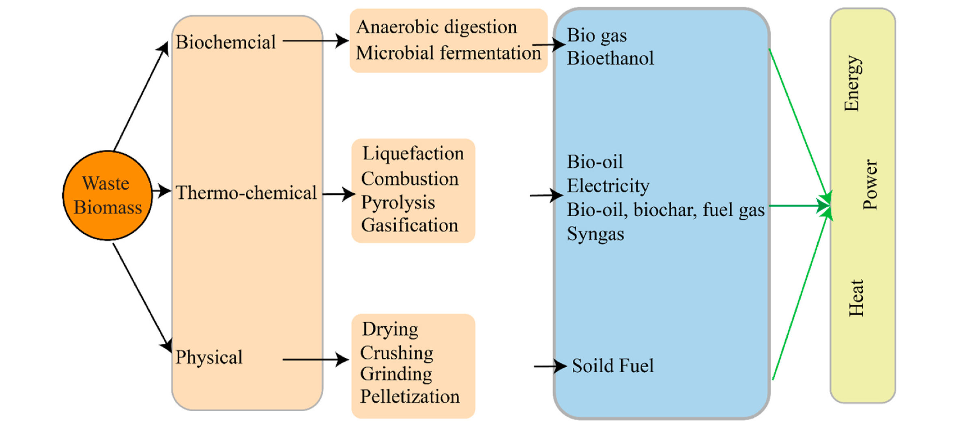

Figure Figuere_energy_pathways_cw. Green waste to energy conversion pathways. (Yadav et al., 2022)

Rosas-Mendoza et al., (2021) presents an interesting study on the anaerobic digestion of industrial citrus solid waste (ISCW) using cattle manure as inoculum. The study was conducted in both batch and semi-continuous modes, and the results showed that up to 60% of volatile solids were removed in the batch mode, while 35% was removed in the semi-continuous mode. Bioenergy potentials of up to 8.79 kWh were obtained for the batches, and a ton of processed oranges was found to have a bioenergy potential of 162 kWh, equivalent to 49 kWh of available electricity. This study highlights the potential of ISCW as a source of bioenergy, and the results could be useful in developing processing technologies for industrial citrus waste.

Mahato et al., (2021) presents a novel approach for the utilization of citrus wastes (CWs) for bioenergy production. The use of steam explosion pre-treatment significantly improved the anaerobic digestibility of CWs by reducing the limonene content. The resulting methane potential increased by 426% compared to untreated samples, and a semi-continuous co-digestion process achieved a methane production rate of 0.555 m3 CH4 kg−1 VS day−1. The economic feasibility of the process was also demonstrated, with an estimated equipment cost of one million USD for a 10,000-ton CWs yearly supply. The study provides valuable insights into the development of sustainable bioenergy production systems using waste resources.

Following the review make for (Putnik et al., 2017) Table Table_tech_citrus_processing have been prepared. Table Table_tech_citrus_processing Technologies for citrus processing review. (Prepared by the author based on the review of Putnik et al., (2017)).

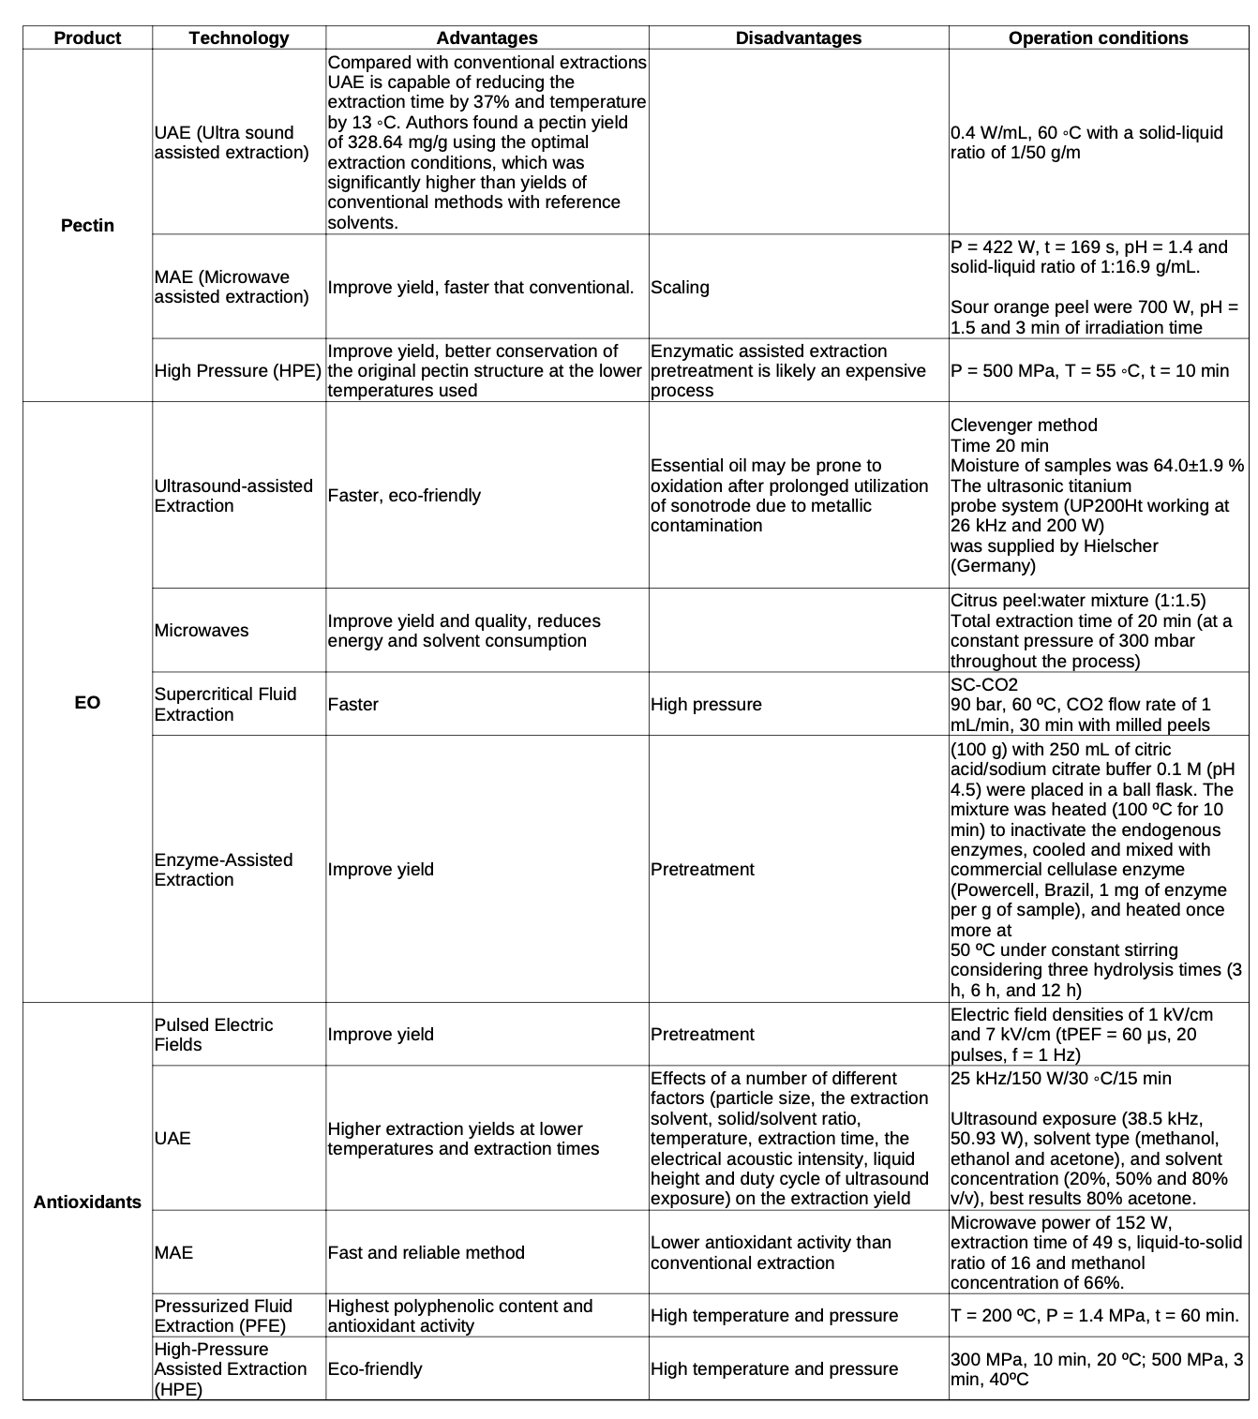

## Exploring the Potential of Value-Added Products in Enhancing the Efficiency and Sustainability of the Citrus Fruit Supply Chain

The literature on the topic of value-added products for the citrus fruit supply chain presents a range of categorizations. Galanaski et al. (2019) categorize these products into production of enzymes, organic acid production, dietary fibers production, production of single cell protein, and candy preparation. In contrast, Klimek-Szczykutowicz et al. (2020) divide citrus lemon value-added products into three different categories: those used in the food industry, those with health or biological activity, and those with cosmetological applications. Zema et al. (2018) take a different approach, dividing the value-added products into those that have a direct use such as agronomic utilization and animal food, and those that are used in biorefinery valorization approaches, such as energy production and added-value product extraction. The Figure Figure_scheme_value_added_products shows an illustrative scheme for added value products of citrus peels waste according to Joglekar et al., (2019).

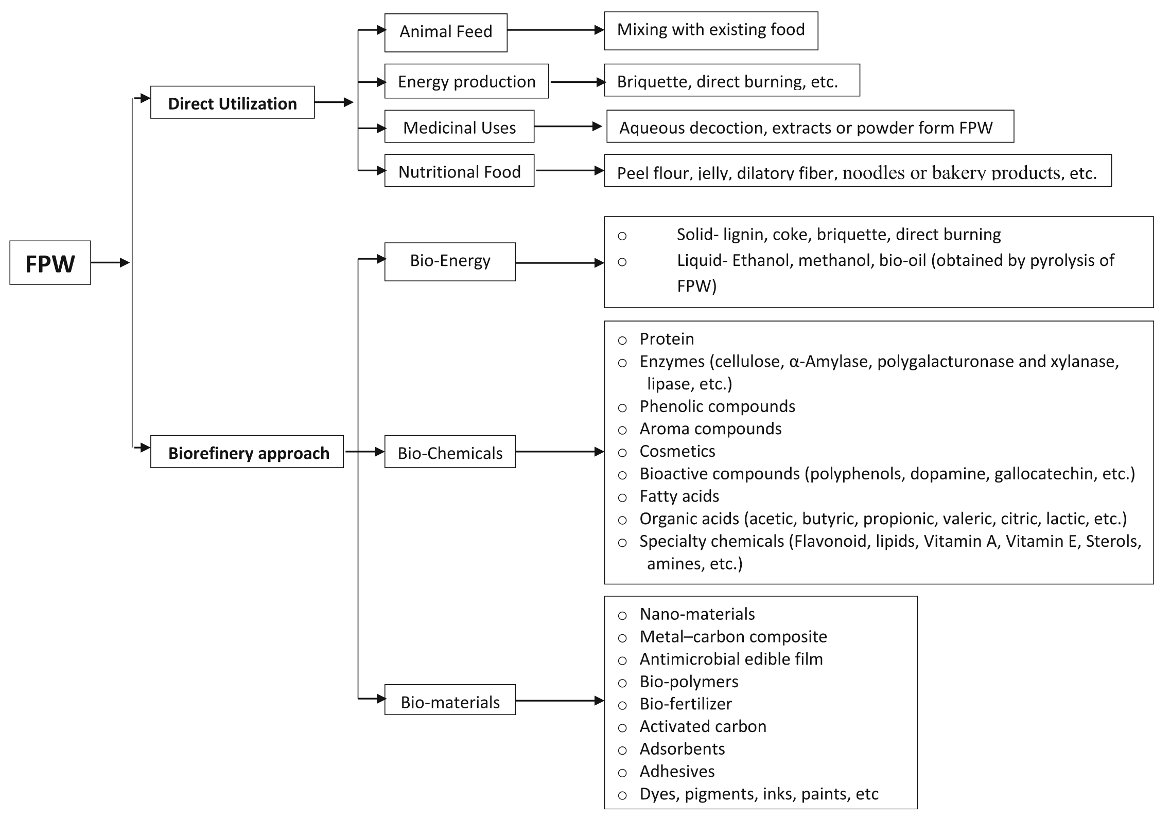Figure Figure_scheme_value_added_products Scheme for added value products of a integrated biorefinery of citrus peel waste (Joglekar et al., 2019)

### Food industry

The Figure citrus_waste_applications presents a comprehensive overview of the various compounds and potential applications of citrus waste, specifically focusing on the flavedo (outer colored part), albedo (white part under the flavedo), pith residue (remains after juice extraction), and seeds. The authors highlight the potential uses of these waste products, including as food additives, flavorings, and medicinal agents. One of the strengths of the article is the level of detail provided regarding the specific compounds found in each waste product and the corresponding potential applications. For example, the authors note that the flavedo contains flavonoids and essential oils such as naringin and limonene, pigments such as caratenoids, and neoeriocitrin and neohesperidin, and that these compounds have potential uses in succade (candied peel), chin pi (dried peel), herbal tea, aroma oils, and digestives. However, the article could benefit from a more in-depth discussion of the current state of research on the specific applications mentioned. For example, the authors mention that citrus waste can be used as "antiseptics, mouth rinse, soaps" but does not provide any details about the studies or research that have been conducted to support these claims. In conclusion, the article presents an interesting and informative overview of the compounds found in citrus waste and the potential applications of these waste products.

(Chavan et al., 2018) research paper also describes the potential uses of citrus peel waste in the food industry. The authors discuss various methods for utilizing citrus peel, such as using it as a source of essential oils, an ingredient in activated carbon, and a component in food-grade kraft paper. The authors also mention the potential for using citrus peel in the development of biodegradable plastics and as an encapsulating agent for phenolic compounds. The research suggests that citrus peel can be a valuable resource for the food industry, and can be used in a variety of applications to improve the sustainability and environmental impact of products. Overall, this paper highlights the potential of citrus peel as a valuable resource, and how it can be used in the food industry to improve sustainability and reduce waste.

(Casas Cardoso et al., 2022) presents an efficient method for valorizing orange peel, a common citrus by-product, by utilizing green extraction, fractionation, and impregnation techniques. The use of supercritical CO2 and ethanol under various pressure and temperature conditions allows for the extraction of valuable compounds from the orange peel. The extracts obtained at 300 bar and 45 °C were found to have strong antioxidant properties and moderate antimicrobial activity. The study then goes on to investigate the impact of different parameters of fractionation such as pressure, temperature, and ethanol percentage on the antioxidant and antimicrobial activity of the extracts. The results show that the fraction obtained at 300 bar, 45 °C, and using 32% ethanol had the strongest antioxidant and antimicrobial activity with a high extraction yield. The study concludes by looking at the potential of the two best extracts to be used as an antioxidant food-grade rigid plastic that would preserve fresh food. The study's use of supercritical CO2 is an environmentally friendly approach and the results show the potential for orange peel to be used as a valuable resource in the food industry.

The review conducted by (O’Shea et al., 2012) highlights the potential of utilizing by-products from fruit and vegetable processing as a cost-effective and sustainable source of functional and nutritional ingredients for the food industry. This not only addresses the issue of waste disposal but also creates a value-added factor for producers, who can capitalize on the high nutritional and functional properties of these by-products. This is of particular significance for ingredient companies, who are constantly seeking cost-effective but value-added ingredients. The use of these by-products also contributes to the development of more healthful food products, as they contain dietary fiber and bioactive compounds that have been linked to various health benefits. Overall, the review emphasizes the importance of recognizing the potential of by-products as a valuable resource for the food industry, and highlights the need for further research and development in this area.

Guclu et al. (2022) conducted a study to examine the impact of four drying methods, namely convective drying (CD), microwave drying (MD), conductive hydro drying, and freeze drying (FD), on the peels of four types of citrus fruits: orange, bitter orange, grapefruit, and lemon. The research findings revealed that the amount of both phenolics and volatiles in the dried samples increased after the drying process. The study indicated that the MD and FD methods were more effective in preserving the color and phenolics of the samples, while the MD and CD methods increased the amount of aroma substances. The results demonstrated that the MD method is a more appropriate drying method for citrus peels due to its shorter duration and positive effects on the phenolic and aroma components. The research holds significance as it highlights the potential of citrus peels, often regarded as process waste in the fruit juice industry, as valuable raw material due to their volatile and bioactive components. The study's results offer valuable insights into the effects of different drying methods on preserving various attributes of citrus peels, including aroma, phenolic composition, microstructure, and color properties. This information can be useful for citrus processors in determining the optimal drying method for their specific application and product.

### Industry

#### Citrus textile

Citrus fibers are used in the textile industry to produce sustainable and eco-friendly fabrics. These fibers are obtained from the waste generated during citrus processing. Vismara, E., (2016) patent describes a process for producing cellulose yarn from citrus fruits such as oranges and lemons. The process involves extracting cellulose from the citrus fruits and converting it into a yarn. The patent states that the process is particularly advantageous as it produces highly pure cellulose from a cheap raw material, such as waste oranges, and can take advantage of the high amounts of citrus fruits that are discarded every year by the food industry. This process represents a profitable alternative to the exclusive use of conventional natural or regenerated cellulose production processes, as it reduces the need for wood pulp and can utilize waste materials. Additionally, the patent highlights the environmental benefits of using waste citrus fruits as a raw material, rather than using wood pulp. The patent also notes that the process is particularly beneficial for countries like Italy, which has a high production of citrus fruits and generates large amounts of waste.

#### Activated carbon

(Weng et al., 2019) presents a method for utilizing citrus peel waste by using potassium carbonate (K2CO3) to extract essential oils and as an activating agent for the preparation of activated carbons. The solid residue remaining after the essential oil extraction is also utilized as a precursor for activated carbons, with a specific surface area of 1846 m2/g and a highly developed microporous structure achieved at a carbonization temperature of 800 ºC. This research demonstrates a sustainable and high-value utilization of citrus peel waste, by utilizing an abundant waste stream to produce valuable products.

(Chavan et al., 2018) discusses the potential use of activated carbon derived from citrus waste as an electrode material in polymer electrolyte membrane fuel cells. The authors note that carbon is a more advantageous electrocatalyst support than metal oxide because of its high specific surface area, stability in acidic and basic medium, and the ability to recover metal catalysts through burning off the carbon support. They cite previous research by Dhelipan, Arunchander, Sahu, and Kalpana (2017) who successfully synthesized activated carbon from orange peel using a chemical activation method with orthophosphoric acid (H3PO4) and pyrolysis at 600 ºC. They also mention that activated carbon has good electrochemical stability and properties, making it a suitable candidate for use in commercial supercapacitors. As the need for sustainable energy sources increases, the authors point out that utilizing bio-waste as a precursor for activated carbon production can help meet the growing demand for activated carbon.

### Human Health

(Oshaghi et al., 2003) evaluated the effectiveness of lemon and balm extracts and essential oils against Anopheles stephensi, a mosquito species that can transmit diseases to humans. The results showed that the oils were more effective than extracts, and lemon oil was as effective as Deet, a synthetic repellent commonly used as a standard. Melissa oil was also effective but less so than lemon oil. The study recommends the use of lemon essential oil as a potential means of personal protection against mosquito vectors of disease, due to its advantages over synthetic compounds. However, the results were found to be marginally superior in repellency for animals than for humans.

The potential health benefits of pectin are increasingly recognized, and (Singhal & Swami Hulle, 2022) provides valuable insights into the extraction and modification of pectin from citrus sources for various industrial applications. As pectin has been found to have diverse pharmaceutical applications, including drug delivery, wound healing, and tissue engineering, the study emphasizes the importance of exploring its potential use in human health from a multidisciplinary perspective. The review highlights the importance of developing innovative approaches to modify pectin to suit specific applications and emphasizes the need for further research to fully exploit the potential of this versatile polysaccharide.

The potential spasmolytic effects of the essential oil of Citrus aurantifolia is highlighted by (Spadaro et al., 2012) with the importance of investigating natural compounds for their therapeutic potential. The identification of major constituents, such as limonene and β-pinene, suggests that these compounds may play a key role in the observed spasmolytic activity. These findings have implications for the development of novel treatments for conditions associated with smooth muscle spasms, including gastrointestinal disorders and uterine dysfunction. Further studies are needed to explore the full therapeutic potential of C. aurantifolia essential oil and its constituents.

(Klimek-Szczykutowicz et al., 2020) discusses the potential health benefits of Citrus limon, or lemon, including its anticancer, antioxidant, anti-inflammatory, and antimicrobial activities. The nanovesicles derived from lemon juice and lemon seed extracts were found to inhibit cancer cell proliferation and induce apoptosis. Lemon flavonoids, such as hesperidin and hesperetin, have antioxidant activity and can stimulate the ERK/Nrf2 signaling pathway. Lemon essential oil and limonin were shown to possess anti-inflammatory and hepatoprotective effects. Lemon extracts and essential oils also have antimicrobial activities against various bacteria, fungi, and viruses, including Streptococcus mutans and Candida glabrata. The results suggest that Citrus limon could potentially be used as a chemopreventive and therapeutic agent for various diseases.

(Riaz et al., 2022) discusses the potential health benefits of citrus fruit, including its antimicrobial, antioxidant, anti-inflammatory, and cardiovascular regulating qualities. The article also discusses the potential for citrus fruits, specifically hesperidin and L-ascorbic acid, to aid in the treatment and prevention of COVID-19. The article references several studies that have found hesperidin to have antiviral effects, including bonding to SARS-CoV-2 proteins. The article concludes that more research is needed to determine the efficacy of a diet rich in citrus fruits for COVID-19 prevention efforts. Additionally, the article discusses the antioxidant properties of citrus fruits and their potential to combat reactive oxygen species that contribute to the development of various diseases.

### Animal feed

The utilization of citrus by-product feedstuffs (BPF) as an alternative feed for ruminants has gained increasing interest due to the rising disposal costs in many parts of the world. (Bampidis & Robinson, 2006) review provides an in-depth evaluation of the physical characteristics, nutrient composition, nutrient digestion, ruminal fermentation, and impact on animal performance of various citrus BPF fed to ruminants, such as fresh citrus pulp, citrus silage, dried citrus pulp, citrus meal and fines, citrus molasses, citrus peel liquor, and citrus activated sludge. The findings suggest that citrus BPF can be used as a high energy feed in ruminant rations to support growth and lactation, with fewer negative effects on rumen fermentation compared to starch-rich feeds. However, the review also highlights the risk of rumen parakeratosis when very high levels of some citrus BPF are fed, particularly when the level of dietary forage is low. This article provides valuable insights for animal nutritionists, feed formulators, and livestock producers to make informed decisions regarding the utilization of citrus BPF as an alternative feed for ruminants.

The study of the nutritional composition of lemon peels as a potential animal feed resource provides useful insights into the utilization of agricultural by-products. The high levels of protein, fiber, and minerals in lemon peels make them a promising source of nutrients for animal diets. The findings of (Janati et al., 2012) show that the nutritional value of lemon peels is comparable to that of other animal feed varieties. Therefore, it is recommended to explore the use of lemon peels as a low-cost and sustainable alternative to conventional animal feedstuffs. Further research could focus on evaluating the performance of different animal species fed with lemon peel-based diets to determine their potential for use in animal production systems.

Alnaimy, (2017) explores the potential benefits of using agro-industrial by-products as feedstuffs for ruminant animals, focusing on citrus pulp as a valuable alternative to conventional feedstuffs. Citrus pulp is a residue of citrus juice canning industry, and it contains high levels of fermentable carbohydrates and energy substrates for ruminal microbes, making it a nutritious feed for ruminants. The study suggests that substituting citrus by-product feedstuffs for starchy feeds can increase fiber digestibility coefficients, and dried citrus pulp can replace up to 30% of the DM in beef cattle and heifer rations. However, it is cautioned that citrus pulp should not be used at high levels for milking cows, as it may decrease milk production. Additionally, the liquid obtained from pressing citrus waste can be concentrated to become citrus molasses, another potential feedstuff for ruminants. Overall, this article highlights the potential economic and nutritional benefits of using citrus by-products as feedstuffs for ruminant animals.

According to Mahato et al., (2018) the production of citrus fruits results in a significant amount of by-products, including peel, segment membranes, and other citrus wastes. These by-products can be used as raw materials for animal feed production. Dried citrus pulp is a common supplement added to the cereal diet for lactating dairy cows, and it can replace up to 20-30% of the concentrated cereal diet for dairy cattle and lactating ewes without adverse effects on their health or milk yield. However, dried citrus pulp is not recommended for pigs and poultry due to the presence of limonin, which is toxic to monogastrics. To increase the density of citrus pulp, it can be sun-dried, pelleted, and ensiled. Citrus molasses, another by-product of citrus juice extraction, can also be used as an animal feed ingredient. It contains about 60-65% sugars and 4-5% citrus pulp, comparable to sugarcane molasses. Overall, citrus wastes derived feed has great potential for animal feed production from an environmental and economic perspective.

Chavan et al., (2018) discusses the potential utilization of citrus seeds, which are commonly considered as waste and discarded. The authors cite previous research by Ammerman and Arrington (1961) that reported the average seed content in dried citrus pulp to be 4.8%. They highlight that citrus seeds are high in protein and can be economically utilized as a protein supplement for livestock.

### Energy production

Forgács et al., (2012) presents a promising solution to the challenge of utilizing citrus wastes for bioenergy production. By applying steam explosion pre-treatment, the limonene content of the wastes was greatly reduced, leading to a significant increase in methane production during anaerobic digestion. The results suggest that the process can be economically feasible for small-scale bioenergy production, with the potential to produce both limonene and methane. This research provides valuable insights into the development of sustainable bioenergy production methods from citrus waste, contributing to the efforts of achieving a more sustainable and diversified energy system.

Lanfranchi, (2012) highlights the importance of biofuels production as a means to reduce energy dependence and meet the targets set by international agreements on energy savings and the use of renewable sources. However, there are concerns that the production of first-generation biofuels from non-food crops may threaten food security and contribute to the volatility of agricultural prices. To address these concerns, the text suggests exploring alternatives such as second-generation biofuels derived from waste in processing and agro-food processing. The implementation of integrated and multifunctional farming could offer opportunities for the processing of biomass and the mobilization of unused biomass in forestry. Overall, the authors emphasizes the need for a comprehensive analysis of the impacts of biofuels production on food security and suggests that second-generation biofuels may be a more promising alternative.

Negro et al., (2016) discusses the potential for bioenergy production from citrus waste through the use of anaerobic digestion or fermentation. The high content of soluble and insoluble carbohydrates in citrus waste makes it a suitable substrate for these processes. However, the presence of limonene, a compound with an inhibitory effect on methane production, is a major challenge. Various strategies, such as co-digestion, have been proposed to overcome this issue. Anaerobic digestion has been shown to be a promising route for bioenergy production from citrus waste, with the potential to generate significant profits for citrus processing plants. Overall, the text provides useful insights into the bioenergy production potential of citrus waste, while highlighting the challenges that must be overcome to realize this potential.

(Chavan et al., 2018) Additionally mention that citrus seeds contain approximately 30% oil by weight, making them a potential source of biodiesel. The authors also mention proximate analysis of flour prepared from unhulled and dehulled citrus seeds, which showed a high content of fat and carbohydrates, and lower levels of crude fiber, crude protein and ash (Akpata & Akubor, 1999). Finally, the authors reference the work of Rashid et al. (2013) who developed citrus seed-based biodiesel oil by using transesterification of the oil with methanol and reported that the methyl esters produced met both ASTM D6751 and EN 14214 biodiesel standards. This research highlights the potential of citrus seeds as a valuable resource for biodiesel production, rather than being discarded as waste.

Rosas-Mendoza et al., (2021) presents a promising approach for the production of bioenergy from industrial citrus solid waste using anaerobic digestion without the elimination of D-limonene. The use of cattle manure as inoculum in both batch and semi-continuous modes resulted in the removal of a significant portion of volatile solids and the generation of methane. The bioenergy potentials obtained for the different batches were significant, and the citrus industry could produce a considerable amount of energy per season. The results of this study highlight the potential of bioenergy production from industrial citrus solid waste and suggest that this approach could contribute to the development of sustainable energy systems. Further studies could focus on optimizing the process parameters and assessing the economic feasibility of large-scale implementation.

Jimenez-Castro et al., (2020) provides insights into the global production of scientific papers related to the recovery of bioenergy from orange industrial waste or by-products. The study highlights two main clusters of literature related to top-cited papers and authorship collaboration networks. The data indicated that Spain, China, and the USA are the top countries in terms of publications, while journals with a higher impact factor related to environmental assessments were responsible for a higher number of publications. The study also suggests that orange peel could be submitted to different pre-treatments to produce bioethanol and methane, as environmentally friendly fuels, and other co-products such as d-limonene and pectin, thereby supporting further research on energy recovery from orange industry solid waste. Overall, this study presents an important perspective on bioenergy production from orange industrial by-products, which can assist future decision-making in this field of science.

Jeong et al., (2021) review article focuses on the potential of citrus peel waste (CPW) as a sustainable biomass for bioenergy production. CPW is an abundant fruit processing waste that can be valorized into fuels and chemicals without competing with human food or animal feed. The review highlights the low lignin content of CPW, which makes it a suitable biomass for biorefinery. However, CPW is high in pectin, which consists of non-fermentable sugars, mainly galacturonic acid. The article describes recent advances in the metabolic engineering of yeast and other microbial strains that can ferment CPW-derived sugars to produce value-added products, such as ethanol and mucic acid. To make CPW-based biorefinery industrially viable, more studies are needed to improve fermentation efficiency and to diversify product profiles. Overall, this article provides valuable insights into the potential of CPW as a sustainable feedstock for bioenergy production.

## Bibliography

Alnaimy, A. (2017). Using of Citrus By-products in Farm Animals Feeding. Open Access Journal of Science, 1(3). <https://doi.org/10.15406/oajs.2017.01.00014>

Ángel Siles López, J., Li, Q., & Thompson, I. P. (2010). Biorefinery of waste orange peel. Critical Reviews in Biotechnology, 30(1), 63–69. [[https://doi.org/10.3109/07388550903425201](https://doi.org/10.3109/07388550903425201](https://doi.org/10.3109/07388550903425201%5D(https://doi.org/10.3109/07388550903425201))

Ashokkumar, V., Flora, G., Sevanan, M., Sripriya, R., Chen, W. H., Park, J.-H., Rajesh banu, J., & Kumar, G. (2023). Technological advances in the production of carotenoids and their applications– A critical review. Bioresource Technology, 367, 128215. <https://doi.org/10.1016/j.biortech.2022.128215>

Balu, A. M., Budarin, V., Shuttleworth, P. S., Pfaltzgraff, L. A., Waldron, K., Luque, R., & Clark, J. H. (2012). Valorisation of Orange Peel Residues: Waste to Biochemicals and Nanoporous Materials. ChemSusChem, 5(9), 1694–1697. [[https://doi.org/10.1002/cssc.201200381](https://doi.org/10.1002/cssc.201200381](https://doi.org/10.1002/cssc.201200381%5D(https://doi.org/10.1002/cssc.201200381))

Bampidis, V. A., & Robinson, P. H. (2006). Citrus by-products as ruminant feeds: A review. Animal Feed Science and Technology, 128(3–4), 175–217. <https://doi.org/10.1016/j.anifeedsci.2005.12.002>

Botero, J. M. (2012). DESIGN AND EVALUATION OF SUSTAINABLE BIOREFINERIES FROM FEEDSTOCKS IN TROPICAL REGIONS. Ingeniería Química, 162.

Boukhatem, M. N. (2016). Cold Pressing, Hydrodistillation and Microwave Dry Distillation of Citrus Essential Oil from Algeria: A Comparative Study. *Plant Biology*, 12.

Boukroufa, M., Boutekedjiret, C., Petigny, L., Rakotomanomana, N., & Chemat, F. (2015). Bio-refinery of orange peels waste: A new concept based on integrated green and solvent free extraction processes using ultrasound and microwave techniques to obtain essential oil, polyphenols and pectin. Ultrasonics Sonochemistry, 24, 72–79. [https://doi.org/10.1016/j.ultsonch.2014.11.015](https://doi.org/10.1016/j.ultsonch.2014.11.015)

Bustamante, J. (2016). Microwave assisted hydro-distillation of essential oils from wet citrus peel waste. Journal of Cleaner Production, 8.

Calinescu, I., Lavric, V., Asofiei, I., Gavrila, A. I., Trifan, A., Ighigeanu, D., Martin, D., & Matei, C. (2017). Microwave assisted extraction of polyphenols using a coaxial antenna and a cooling system. Chemical Engineering and Processing: Process Intensification, 122, 373–379. <https://doi.org/10.1016/j.cep.2017.02.003>

Casas Cardoso, L., Cejudo Bastante, C., Mantell Serrano, C., & Martínez de la Ossa, E. J. (2022). Application of Citrus By-Products in the Production of Active Food Packaging. Antioxidants, 11(4), 738. [https://doi.org/10.3390/antiox11040738](https://doi.org/10.3390/antiox11040738)

Ceron, I., & Cardona, C. (2011). Evaluación del proceso integral para la obtención de aceite esencial y pectina a partir de cáscara de naranja. Ingeniería y ciencia, 7(13), 65–86.

Chavan, P., Singh, A. K., & Kaur, G. (2018). Recent progress in the utilization of industrial waste and by‐products of citrus fruits: A review. Journal of Food Process Engineering, 41(8), e12895. [[https://doi.org/10.1111/jfpe.12895](https://doi.org/10.1111/jfpe.12895](https://doi.org/10.1111/jfpe.12895%5D(https://doi.org/10.1111/jfpe.12895))

Chávez-González, M. L., López-López, L. I., Rodríguez-Herrera, R., Contreras-Esquivel, J. C., & Aguilar, C. N. (2016). Enzyme-assisted extraction of citrus essential oil. Chemical Papers, 70(4). <https://doi.org/10.1515/chempap-2015-0234>

Chemat, F. (2017). Review of Green Food Processing techniques. Preservation, transformation, and extraction. Innovative Food Science and Emerging Technologies, 41, 21. [http://dx.doi.org/10.1016/j.ifset.2017.04.016](http://dx.doi.org/10.1016/j.ifset.2017.04.016)

Chémat, F., & Vorobiev, E. (Eds.). (2019). Green food processing techniques: Preservation, transformation and extraction. Academic Press, an imprint of Elsevier.

Dávila, J. A., Rosenberg, M., & Cardona, C. A. (2015). Techno-economic and Environmental Assessment of p-Cymene and Pectin Production from Orange Peel. Waste and Biomass Valorization, 6(2), 253–261. [[https://doi.org/10.1007/s12649-014-9339-y](https://doi.org/10.1007/s12649-014-9339-y](https://doi.org/10.1007/s12649-014-9339-y%5D(https://doi.org/10.1007/s12649-014-9339-y))

Dao, T. P., Tran, T. H., Nguyen, P. T. N., Tran, T. K. N., Ngo, T. C. Q., Anh, T. T., Toan, T. Q., Quan, P. M., & Linh, H. T. K. (2020). Optimization of microwave assisted hydrodistillation of essential oil from lemon (Citrus aurantifolia) leaves: Response surface methodology studies. Materials Science and Engineering, 9.

Ferhat, M. A., Meklati, B. Y., & Chemat, F. (2007). Comparison of different isolation methods of essential oil from Citrus fruits: Cold pressing, hydrodistillation and microwave `dry’ distillation. 11.

Fidalgo, A., Ciriminna, R., Carnaroglio, D., Tamburino, A., Cravotto, G., Grillo, G., Ilharco, L. M., & Pagliaro, M. (2016). Eco-Friendly Extraction of Pectin and Essential Oils from Orange and Lemon Peels. ACS Sustainable Chemistry & Engineering, 4(4), 2243–2251. [[https://doi.org/10.1021/acssuschemeng.5b01716](https://doi.org/10.1021/acssuschemeng.5b01716](https://doi.org/10.1021/acssuschemeng.5b01716%5D(https://doi.org/10.1021/acssuschemeng.5b01716))

Forgács, G., Pourbafrani, M., Niklasson, C., Taherzadeh, M. J., & Hováth, I. S. (2012). Methane production from citrus wastes: Process development and cost estimation. Journal of Chemical Technology & Biotechnology, 87(2), 250–255. <https://doi.org/10.1002/jctb.2707>

Galanakis, C. (Ed.). (2019). Valorization of fruit processing by-products (1st ed.). Elsevier.

Garcia-Garcia, G., Rahimifard, S., Mathau, A. S., & Dugmore, T. I. J. (2019). Life-Cycle Analysis of Microwave Assisted Pectin Extraction at Pilot-scale.

Garrido, G., Chou, W.-H., Vega, C., Goïty, L., & Valdés, M. (2019). Influence of extraction methods on fatty acid composition, total phenolic content and antioxidant capacity of Citrus seed oils from the Atacama Desert, Chile. Journal of Pharmacy & Pharmacognosy Research, 7(6), 389–407.

Golmohammadi, M., Borghei, A., Zenouzi, A., Ashrafi, N., & Taherzadeh, M. J. (2018). Optimization of essential oil extraction from orange peels using steam explosion. Heliyon, 4(11), e00893. <https://doi.org/10.1016/j.heliyon.2018.e00893>

González-Rivera, J., Spepi, A., Ferrari, C., Duce, C., Longo, I., Falconieri, D., Piras, A., & Tinè, M. R. (2016). Novel configurations for a citrus waste based biorefinery: From solventless to simultaneous ultrasound and microwave assisted extraction. Green Chemistry, 18(24), 6482–6492. [https://doi.org/10.1039/C6GC02200F](https://doi.org/10.1039/C6GC02200F)

Guclu, G., Polat, S., Kelebek, H., Capanoglu, E., & Selli, S. (2022). Elucidation of the impact of four different drying methods on the phenolics, volatiles, and color properties of the peels of four types of citrus fruits. Journal of the Science of Food and Agriculture, 102(13), 6036–6046. [[https://doi.org/10.1002/jsfa.11956](https://doi.org/10.1002/jsfa.11956](https://doi.org/10.1002/jsfa.11956%5D(https://doi.org/10.1002/jsfa.11956))

Harrington, R. A., Adhikari, V., Rayner, M., & Scarborough, P. (2019). Nutrient composition databases in the age of big data: FoodDB, a comprehensive, real-time database infrastructure. BMJ Open, 9(6), e026652. <https://doi.org/10.1136/bmjopen-2018-026652>

Hilali, S., Fabiano-Tixier, A.-S., Ruiz, K., Hejjaj, A., Ait Nouh, F., Idlimam, A., Bily, A., Mandi, L., & Chemat, F. (2019). Green Extraction of Essential Oils, Polyphenols, and Pectins from Orange Peel Employing Solar Energy: Toward a Zero-Waste Biorefinery. ACS Sustainable Chemistry & Engineering, 7(13), 11815–11822. [https://doi.org/10.1021/acssuschemeng.9b02281](https://doi.org/10.1021/acssuschemeng.9b02281)

Instituto Colombiano & de Bienestar Familiar. (2018). Tabla de Composición de Alimentos Colombianos 2018. [[https://www.icbf.gov.co/system/files/tcac_web.pdf](https://www.icbf.gov.co/system/files/tcac_web.pdf](https://www.icbf.gov.co/system/files/tcac_web.pdf%5D(https://www.icbf.gov.co/system/files/tcac_web.pdf))

Janati, S. S. F., Beheshti, H. R., Feizy, J., & Fahim, N. K. (2012). CHEMICAL COMPOSITION OF LEMON (CITRUS LIMON) AND PEELS ITS CONSIDERATIONS AS ANIMAL FOOD. 5.

Jesus, D. F., Leite, M. F., Silva, L. F. M., Modesta, R. D., Matta, V. M., & Cabral, L. M. C. (2007). Orange (Citrus sinensis) juice concentration by reverse osmosis. *Journal of Food Engineering*, *81*(2), 287–291. <https://doi.org/10.1016/j.jfoodeng.2006.06.014>

Jeong, D., Park, H., Jang, B.-K., Ju, Y., Shin, M. H., Oh, E. J., Lee, E. J., & Kim, S. R. (2021). Recent advances in the biological valorization of citrus peel waste into fuels and chemicals. Bioresource Technology, 323, 124603. [[https://doi.org/10.1016/j.biortech.2020.124603](https://doi.org/10.1016/j.biortech.2020.124603](https://doi.org/10.1016/j.biortech.2020.124603%5D(https://doi.org/10.1016/j.biortech.2020.124603))

Jimenez-Castro, M. P., Buller, L. S., Sganzerla, W. G., & Forster-Carneiro, T. (2020). Bioenergy production from orange industrial waste: A case study. Biofuels Bioproducts & Biorefining-Biofpr, 14(6), 1239–1253. <https://doi.org/10.1002/bbb.2128>

Joglekar, S. N., Pathak, P. D., Mandavgane, S. A., & Kulkarni, B. D. (2019). Process of fruit peel waste biorefinery: A case study of citrus waste biorefinery, its environmental impacts and recommendations. Environmental Science and Pollution Research, 26(34), 34713–34722. [[https://doi.org/10.1007/s11356-019-04196-0](https://doi.org/10.1007/s11356-019-04196-0](https://doi.org/10.1007/s11356-019-04196-0%5D(https://doi.org/10.1007/s11356-019-04196-0))

Klimek-Szczykutowicz, Szopa, & Ekiert. (2020). Citrus limon (Lemon) Phenomenon—A Review of the Chemistry, Pharmacological Properties, Applications in the Modern Pharmaceutical, Food, and Cosmetics Industries, and Biotechnological Studies. Plants, 9(1), 119. <https://doi.org/10.3390/plants9010119>

Kontogiorgos, V. (Ed.). (2020). Pectin: Technological and Physiological Properties. Springer International Publishing. <https://doi.org/10.1007/978-3-030-53421-9>

Koulouris, A., & Demetri Petrides. (2020). Pectin Production from Citrus Peels—Process Modeling and Techno-Economic Assessment (TEA) with SuperPro Designer. <https://doi.org/10.13140/RG.2.2.19184.89600>

Klimek-Szczykutowicz, Szopa, & Ekiert. (2020). Citrus limon (Lemon) Phenomenon—A Review of the Chemistry, Pharmacological Properties, Applications in the Modern Pharmaceutical, Food, and Cosmetics Industries, and Biotechnological Studies. Plants, 9(1), 119. [[https://doi.org/10.3390/plants9010119](https://doi.org/10.3390/plants9010119](https://doi.org/10.3390/plants9010119%5D(https://doi.org/10.3390/plants9010119))

Lanfranchi, M. (2012). Economic analysis on the enhancement of citrus waste for energy production. Journal of Essential Oil Research, 24(6), 583–591. <https://doi.org/10.1080/10412905.2012.739788>

Lohrasbi, M., Pourbafrani, M., Niklasson, C., & Taherzadeh, M. J. (2010). Process design and economic analysis of a citrus waste biorefinery with biofuels and limonene as products. Bioresource Technology, 101(19), 7382–7388. [[https://doi.org/10.1016/j.biortech.2010.04.078](https://doi.org/10.1016/j.biortech.2010.04.078](https://doi.org/10.1016/j.biortech.2010.04.078%5D(https://doi.org/10.1016/j.biortech.2010.04.078))

Mahato, N., Sharma, K., Sinha, M., & Cho, M. H. (2018). Citrus waste derived nutra-/pharmaceuticals for health benefits: Current trends and future perspectives. Journal of Functional Foods, 40, 307–316. [[https://doi.org/10.1016/j.jff.2017.11.015](https://doi.org/10.1016/j.jff.2017.11.015](https://doi.org/10.1016/j.jff.2017.11.015%5D(https://doi.org/10.1016/j.jff.2017.11.015))

Mahato, N., Sharma, K., Sinha, M., Dhyani, A., Pathak, B., Jang, H., Park, S., Pashikanti, S., & Cho, S. (2021). Biotransformation of Citrus Waste-I: Production of Biofuel and Valuable Compounds by Fermentation. Processes, 9(2), Article 2. <https://doi.org/10.3390/pr9020220>

Myrtsi, E. D., Koulocheri, S. D., Evergetis, E., & Haroutounian, S. A. (2022). Agro-industrial co-products upcycling: Recovery of carotenoids and fine chemicals from Citrus sp. juice industry co-products. Industrial Crops and Products, 186, 115190. [[https://doi.org/10.1016/j.indcrop.2022.115190](https://doi.org/10.1016/j.indcrop.2022.115190](https://doi.org/10.1016/j.indcrop.2022.115190%5D(https://doi.org/10.1016/j.indcrop.2022.115190))

Ndayishimiye, J., Getachew, A. T., & Chun, B. S. (2017). Comparison of Characteristics of Oils Extracted from a Mixture of Citrus Seeds and Peels Using Hexane and Supercritical Carbon Dioxide. Waste and Biomass Valorization, 8(4), 1205–1217. <https://doi.org/10.1007/s12649-016-9697-8>

Negro, V., Mancini, G., Ruggeri, B., & Fino, D. (2016). Citrus waste as feedstock for bio-based products recovery: Review on limonene case study and energy valorization. Bioresource Technology, 214, 806–815. <https://doi.org/10.1016/j.biortech.2016.05.006>

Negro, V., Ruggeri, B., Fino, D., & Tonini, D. (2017). Life cycle assessment of orange peel waste management. Resources, Conservation and Recycling, 127, 148–158. <https://doi.org/10.1016/j.resconrec.2017.08.014>

Nnamdi, U. B., Onyejiuwa, C. T., & Ogbuke, C. R. (2020). Review of Orange Juice Extractor Machines. Advances in Science, Technology and Engineering Systems Journal, 5(5), 485–492. https://doi.org/10.25046/aj050560

Nwobi, B., Ofoegbu, O., & Adesina, O. (2011). Extraction and qualitative assessment of African sweet orange seed oil. African Journal of Food, Agriculture, Nutrition and Development, 6(2). <https://doi.org/10.4314/ajfand.v6i2.71747>

Olaniyan, A. M. (2010). Development of a small scale orange juice extractor. Journal of Food Science and Technology, 47(1), 105–108. <https://doi.org/10.1007/s13197-010-0002-8>

Oshaghi, M., Ghalandari, R., Vatandoost, H., Shayeghi, M., Kamali-nejad, M., Tourabi-Khaledi, H., Abolhassani, M., & Hashemzadeh, M. (2003). Repellent Effect of Extracts and Essential Oils of Citrus limon (Rutaceae) and Melissa officinalis (Labiatae) Against Main Malaria Vector, Anopheles stephensi (Diptera: Culicidae). 32(4), 7.

O’Shea, N., Arendt, E. K., & Gallagher, E. (2012). Dietary fibre and phytochemical characteristics of fruit and vegetable by-products and their recent applications as novel ingredients in food products. Innovative Food Science & Emerging Technologies, 16, 1–10. <https://doi.org/10.1016/j.ifset.2012.06.002>

Park, Y.-S., Kim, I., Dhungana, S. K., Park, E.-J., Park, J.-J., Kim, J.-H., & Shin, D.-H. (2021). Quality Characteristics and Antioxidant Potential of Lemon (Citrus limon Burm. F.) Seed Oil Extracted by Different Methods. Frontiers in Nutrition, 8, 644406. <https://doi.org/10.3389/fnut.2021.644406>

Patsalou, M., Menikea, K. K., Makri, E., Vasquez, M. I., Drouza, C., & Koutinas, M. (2017). Development of a citrus peel-based biorefinery strategy for the production of succinic acid. Journal of Cleaner Production, 166, 706–716. [[https://doi.org/10.1016/j.jclepro.2017.08.039](https://doi.org/10.1016/j.jclepro.2017.08.039](https://doi.org/10.1016/j.jclepro.2017.08.039%5D(https://doi.org/10.1016/j.jclepro.2017.08.039))

Pérez, M. I. A., Martínez, M. D. C., & Chavez, I. F. F. (2012). Extracción de pectina a partir de lima persa (Citrus Latifolia Tanaka) de primera calidad. 4, 3.

Pingret, D., Fabiano-Tixier, A.-S., & Chemat, F. (2014). An Improved Ultrasound Clevenger for Extraction of Essential Oils. Food Analytical Methods, 7(1), 9–12. https://doi.org/10.1007/s12161-013-9581-0

Pourbafrani, M., Forgács, G., Horváth, I. S., Niklasson, C., & Taherzadeh, M. J. (2010). Production of biofuels, limonene and pectin from citrus wastes. Bioresource Technology, 101(11), 4246–4250. https://doi.org/10.1016/j.biortech.2010.01.077

Phucharoenrak, P., Muangnoi, C., & Trachootham, D. (2022). A Green Extraction Method to Achieve the Highest Yield of Limonin and Hesperidin from Lime Peel Powder (Citrus aurantifolia). Molecules, 27(3), 820. [[https://doi.org/10.3390/molecules27030820](https://doi.org/10.3390/molecules27030820](https://doi.org/10.3390/molecules27030820%5D(https://doi.org/10.3390/molecules27030820))

Prakash Maran, J., Sivakumar, V., Thirugnanasambandham, K., & Sridhar, R. (2013). Optimization of microwave assisted extraction of pectin from orange peel. Carbohydrate Polymers, 97(2), 703–709. <https://doi.org/10.1016/j.carbpol.2013.05.052>

Putnik, P., Bursać Kovačević, D., Režek Jambrak, A., Barba, F., Cravotto, G., Binello, A., Lorenzo, J., & Shpigelman, A. (2017). Innovative “Green” and Novel Strategies for the Extraction of Bioactive Added Value Compounds from Citrus Wastes—A Review. Molecules, 22(5), 680. [https://doi.org/10.3390/molecules22050680](https://doi.org/10.3390/molecules22050680)

Rafiq, S., Kaul, R., Sofi, S. A., Bashir, N., Nazir, F., & Ahmad Nayik, G. (2018). Citrus peel as a source of functional ingredient: A review. Journal of the Saudi Society of Agricultural Sciences, 17(4), 351–358. [https://doi.org/10.1016/j.jssas.2016.07.006](https://doi.org/10.1016/j.jssas.2016.07.006)

Rezzadori, K., Benedetti, S., & Amante, E. R. (2012). Proposals for the residues recovery: Orange waste as raw material for new products. Food and Bioproducts Processing, 90(4), 606–614. [[https://doi.org/10.1016/j.fbp.2012.06.002](https://doi.org/10.1016/j.fbp.2012.06.002](https://doi.org/10.1016/j.fbp.2012.06.002%5D(https://doi.org/10.1016/j.fbp.2012.06.002))

Riaz, S., Ahmad, A., Farooq, R., Hussain, N., Riaz, T., Hussain, K., & Mazahir, M. (2022). Citrus: An Overview of Food Uses and Health Benefits. In Advances in Citrus Production and Research [Working Title]. IntechOpen. <https://doi.org/10.5772/intechopen.106420>

Rivas-Cantu, R. C., Jones, K. D., & Mills, P. L. (2013). A citrus waste-based biorefinery as a source of renewable energy: Technical advances and analysis of engineering challenges. Waste Management & Research: The Journal for a Sustainable Circular Economy, 31(4), 413–420. [[https://doi.org/10.1177/0734242X13479432](https://doi.org/10.1177/0734242X13479432](https://doi.org/10.1177/0734242X13479432%5D(https://doi.org/10.1177/0734242X13479432))

Rosas-Mendoza, E. S., Alvarado-Vallejo, A., Vallejo-Cantú, N. A., Snell-Castro, R., Martínez-Hernández, S., & Alvarado-Lassman, A. (2021). Batch and Semi-Continuous Anaerobic Digestion of Industrial Solid Citrus Waste for the Production of Bioenergy. Processes, 9(4), Article 4. <https://doi.org/10.3390/pr9040648>

Sabater, C., Villamiel, M., & Montilla, A. (2022). Integral use of pectin-rich by-products in a biorefinery context: A holistic approach. Food Hydrocolloids, 128, 107564. <https://doi.org/10.1016/j.foodhyd.2022.107564>

Santiago, B., Moreira, M. T., Feijoo, G., & González-García, S. (2020). Identification of environmental aspects of citrus waste valorization into D-limonene from a biorefinery approach. Biomass and Bioenergy, 143, 105844. [[https://doi.org/10.1016/j.biombioe.2020.105844](https://doi.org/10.1016/j.biombioe.2020.105844](https://doi.org/10.1016/j.biombioe.2020.105844%5D(https://doi.org/10.1016/j.biombioe.2020.105844))

Satari, B., & Karimi, K. (2018). Citrus processing wastes: Environmental impacts, recent advances, and future perspectives in total valorization. Resources, Conservation and Recycling, 129, 153–167. [[https://doi.org/10.1016/j.resconrec.2017.10.032](https://doi.org/10.1016/j.resconrec.2017.10.032](https://doi.org/10.1016/j.resconrec.2017.10.032%5D(https://doi.org/10.1016/j.resconrec.2017.10.032))

Sharma, K., Mahato, N., & Lee, Y. R. (2019). Extraction, characterization and biological activity of citrus flavonoids. Reviews in Chemical Engineering, 35(2), 265–284. <https://doi.org/10.1515/revce-2017-0027>

Singhal, S., & Swami Hulle, N. R. (2022). Citrus pectins: Structural properties, extraction methods, modifications and applications in food systems – A review. Applied Food Research, 2(2), 100215. https://doi.org/10.1016/j.afres.2022.100215

Singanusong, R., Nipornram, S., Tochampa, W., & Rattanatraiwong, P. (2015). Low Power Ultrasound-Assisted Extraction of Phenolic Compounds from Mandarin (Citrus reticulata Blanco cv. Sainampueng) and Lime (Citrus aurantifolia) Peels and the Antioxidant. Food Analytical Methods, 8(5), 1112–1123. <https://doi.org/10.1007/s12161-014-9992-6>

Song, Z., Wei, X., Xie, M., Zhao, X., Sun, J., Mao, Y., Wang, X., & Wang, W. (2022). Study on the microwave extraction process and product distribution of essential oils from citrus peel. Chemical Engineering and Processing - Process Intensification, 171, 108726. https://doi.org/10.1016/j.cep.2021.108726

Spadaro, F., Costa, R., Circosta, C., & Occhiuto, F. (2012). Volatile Composition and Biological Activity of Key Lime Citrus aurantifolia Essential Oil. Natural Product Communications, 7(11), 1934578X1200701. https://doi.org/10.1177/1934578X1200701128

Teigiserova, D. A., Hamelin, L., Tiruta-Barna, L., Ahmadi, A., & Thomsen, M. (2022). Circular bioeconomy: Life cycle assessment of scaled-up cascading production from orange peel waste under current and future electricity mixes. Science of The Total Environment, 812, 152574. <https://doi.org/10.1016/j.scitotenv.2021.152574>

Tuan, N. T., et. al. (2019). One step extraction of essential oils and pectin from pomelo (Citrus grandis) peels. Chemical Engineering & Processing: Process Intensification 142.

U.S. Department of Agriculture, Agricultural Research Service. (2019). FoodData Central. [[https://fdc.nal.usda.gov/](https://fdc.nal.usda.gov/](https://fdc.nal.usda.gov/%5D(https://fdc.nal.usda.gov/))

U.S. Department of Agriculture, Agricultural Research Service. (1956). CHEMISTRY AND TECHNOLOGY OF CITRUS, CITRUS PRODUC; AND BYPRODUCTS. AGRICUL.TURE HANDBOOK. No 98. <https://naldc.nal.usda.gov/download/CAT87210994/PDF>

Vismara, E., S., Adriana Maria. (2016). PRODUCTION OF TEXTILE FROM CITRUS FRUIT. European Patent. [<https://data.epo.org/publication-server/document?iDocId=5844418&iFormat=0](https://data.epo.org/publication-server/document?iDocId=5844418&iFormat=0>)

Weng, J., Wei, M.-M., Wu, S.-J., Liu, Y.-Q., Li, S.-R., Ye, Y.-Y., Wang, M., & Wang, D. (2019). High-value utilization of citrus peel: Efficient extraction of essential oil and preparation of activated carbon. BioResources, 14(2), 3899–3913. [[https://doi.org/10.15376/biores.14.2.3899-3913](https://doi.org/10.15376/biores.14.2.3899-3913](https://doi.org/10.15376/biores.14.2.3899-3913%5D(https://doi.org/10.15376/biores.14.2.3899-3913))

Wu, G. A., Terol, J., Ibanez, V., López-García, A., Pérez-Román, E., Borredá, C., Domingo, C., Tadeo, F. R., Carbonell-Caballero, J., Alonso, R., Curk, F., Du, D., Ollitrault, P., Roose, M. L., Dopazo, J., Gmitter, F. G., Rokhsar, D. S., & Talon, M. (2018). Genomics of the origin and evolution of Citrus. Nature, 554(7692), 311–316. <https://doi.org/10.1038/nature25447>

Yadav, V., Sarker, A., Yadav, A., Miftah, A. O., Bilal, M., & Iqbal, H. M. N. (2022). Integrated biorefinery approach to valorize citrus waste: A sustainable solution for resource recovery and environmental management. Chemosphere, 293, 133459. [[https://doi.org/10.1016/j.chemosphere.2021.133459](https://doi.org/10.1016/j.chemosphere.2021.133459](https://doi.org/10.1016/j.chemosphere.2021.133459%5D(https://doi.org/10.1016/j.chemosphere.2021.133459))

Zayed, A., Badawy, M. T., & Farag, M. A. (2021). Valorization and extraction optimization of Citrus seeds for food and functional food applications. Food Chemistry, 355, 129609. <https://doi.org/10.1016/j.foodchem.2021.129609>

Zhang, S., Yang, X., Zhang, H., Chu, C., Zheng, K., Ju, M., & Liu, L. (2019). Liquefaction of Biomass and Upgrading of Bio-Oil: A Review. Molecules, 24(12), 2250. [[https://doi.org/10.3390/molecules24122250](https://doi.org/10.3390/molecules24122250](https://doi.org/10.3390/molecules24122250%5D(https://doi.org/10.3390/molecules24122250))

Zema, D. A., Calabrò, P. S., Folino, A., Tamburino, V., Zappia, G., & Zimbone, S. M. (2018). Valorisation of citrus processing waste: A review. Waste Management, 80, 252–273. [[https://doi.org/10.1016/j.wasman.2018.09.024](https://doi.org/10.1016/j.wasman.2018.09.024](https://doi.org/10.1016/j.wasman.2018.09.024%5D(https://doi.org/10.1016/j.wasman.2018.09.024))

## Anexxo I

![image.png](../assets/image_1667868907494_0.png)

![image.png](../assets/image_1667868936795_0.png)

![fdc.nal.usda.gov_fdc-app.html.png](../assets/fdc.nal.usda.gov_fdc-app.html_1668474593824_0.png)

1. Microwave-assisted extraction MAE technology was officially included in the Environmental Protection Agency (EPA) Method 3546. Microwave extraction occurs as the result of changes in the cell structure caused by electromagnetic waves. Microwave extraction is safe and versatile and saves time and energy compared to conventional methods. Also is a safe, cheap, and rapid method for extracting organic compounds from environmental matrices. There exist various patents for this technology. Particularly, it is useful for the optimization of manufacturing processes in a less centralized system (Chémat & Vorobiev, 2019, Chemat et al., 2017).